**Prerequisites**:

Reactjs library

React dom library

Babel (js preprocessor) – to compile next generation js code we write to the code that runs fine in the browser

webpack to import css files into javascript files

BEST PRACTICE:

Use Class based components for state management and functional components for presentation

Run any react project from terminal

1) Run "npm install" in the extracted folder

2) Run "npm start" to view the project

Definitions:

React Hooks – react functions u can add into any functional components

Reference:

https://www.udemy.com/course/react-the-complete-guide-incl-redux/

**Without react:**

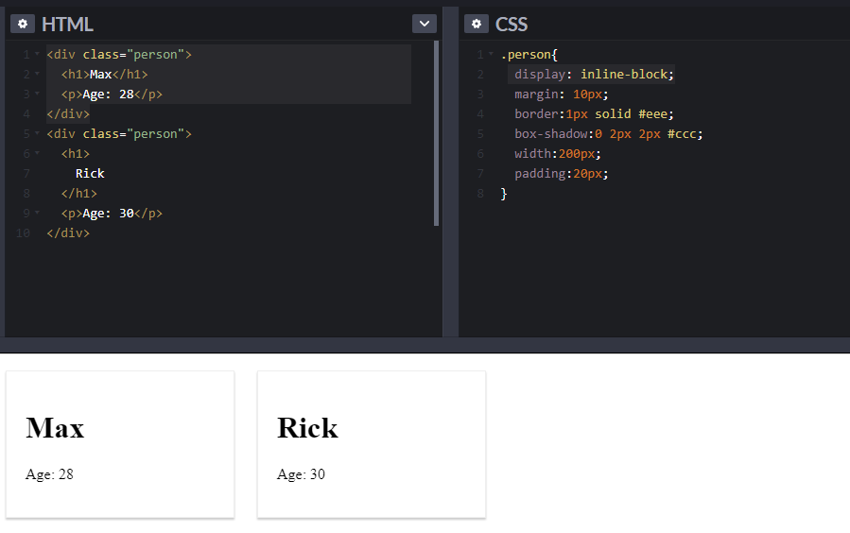

**Writing a react component**: React component is a function

* Function name must start with Uppercase
* Html inside javascript – JSX
* Using document.queryselector(‘#elementid’) to find the element by its id
* Using React to render html to a div. Notice class in HTML is changed to className. Class is a keyword in javascript, so use className instead for the css to apply.

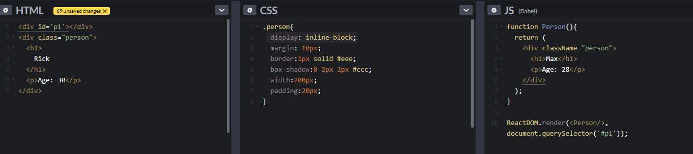

Reusable React Component:

* React allows passing arguments in function, props in the below screen but can be any name.
* Properties can be passed in the render and can be accesses in the component using single curly braces { }

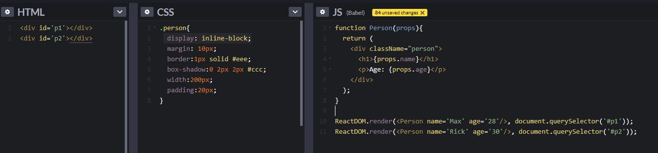

Efficient way of writing multiple renderDOM into one to create single page applications

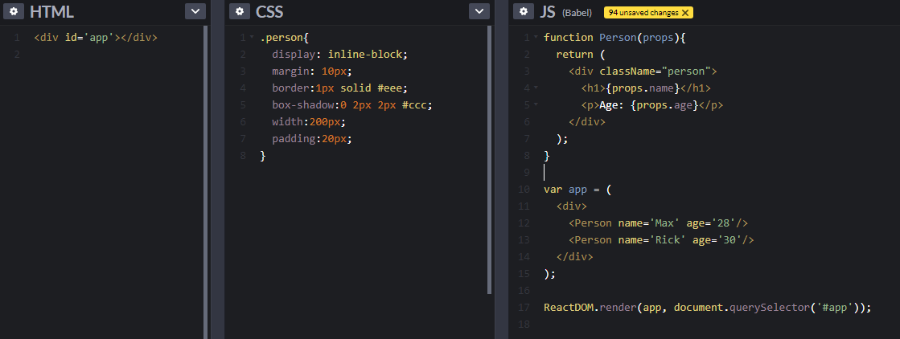

Single page vs multipage applications

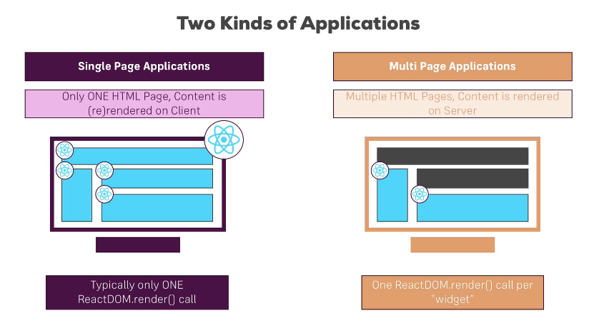

**ES6 JavaScript**

**Arrow Functions**

Regular js function

*Function fun(name){*

*Console.log(name);*

*}*

ES6 Javascript function: solves problem with this keyword

*Const fun=(name)=>{*

*};*

Other form: no need for parenthesis for arguments when only one argument and no need to add return after arrow. Below function will return 4.

*Const multiply= number => number*2*

*Console.log(Multiply(2))*

**Exports and Imports**

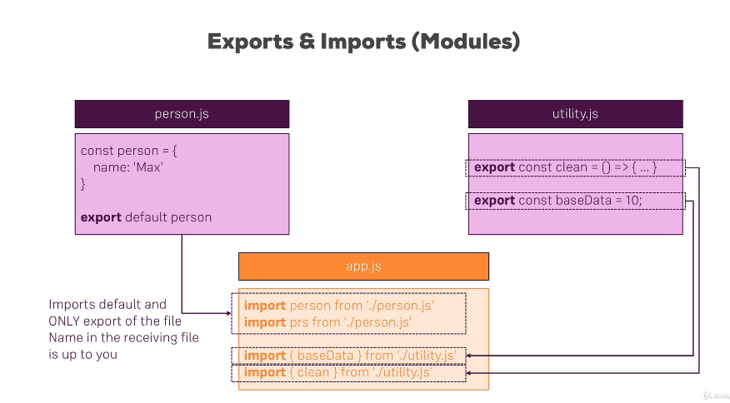

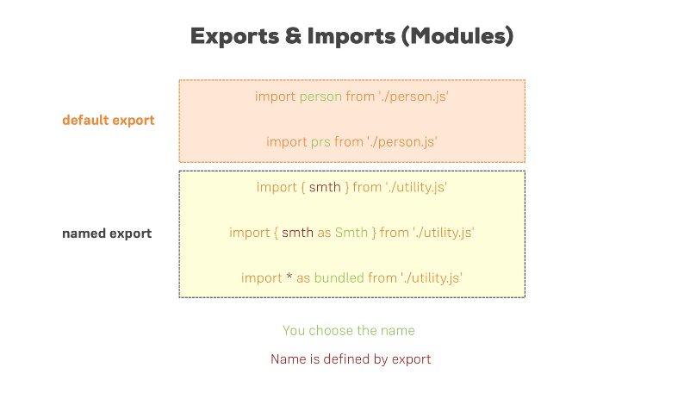

**Classes:** blueprints for objects

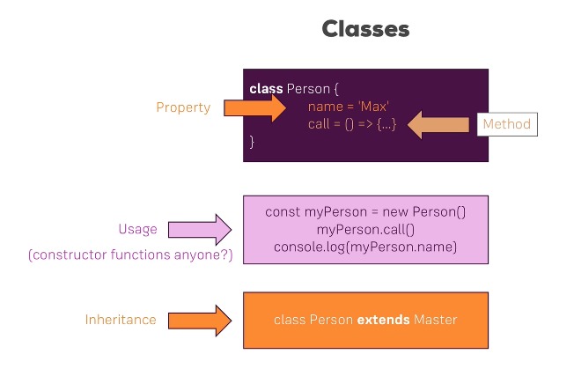

**Class Creation and usage with inheritance**

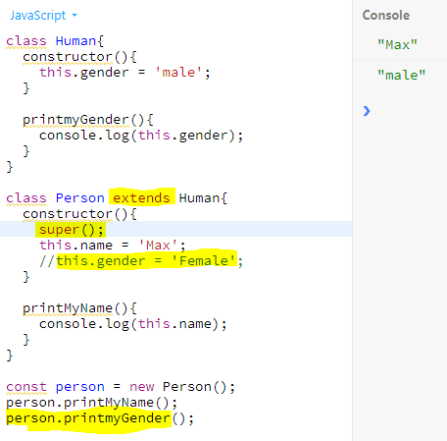

**ES6 VS ES7**

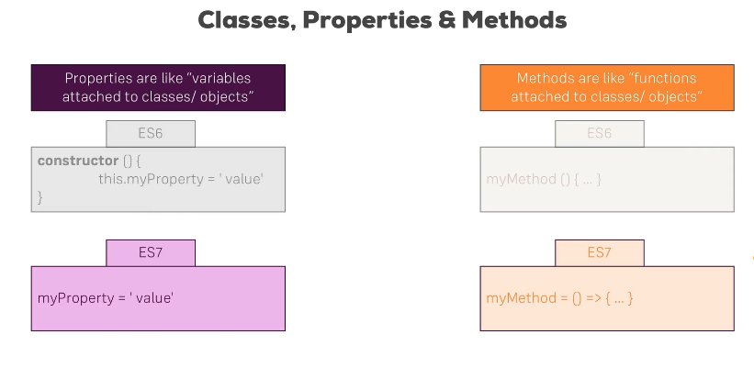

**Same inheritance example using next gen es7, using arrow function and without constructor or super keyword**

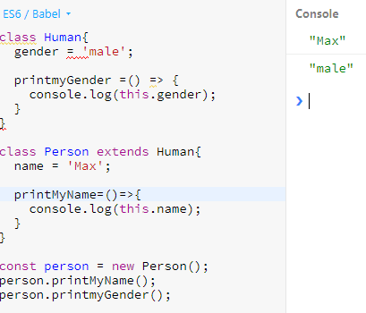

**Spread vs Rest Operator**

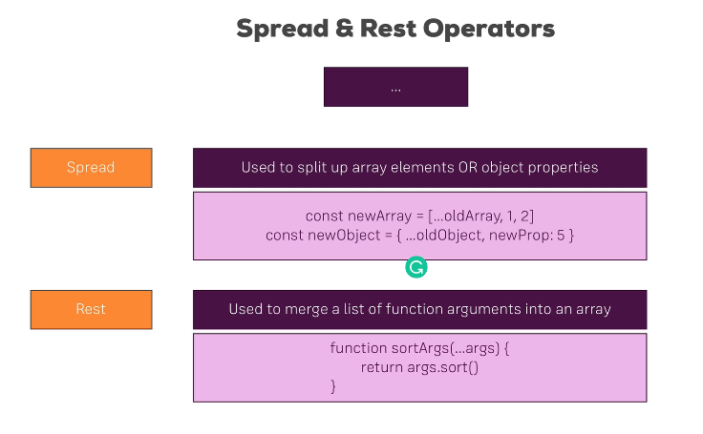

**Example with and without spread, rest operator in arrays, objects and methods**

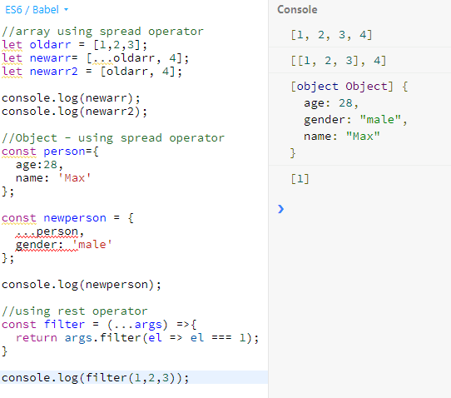

**Array and object destructuring**

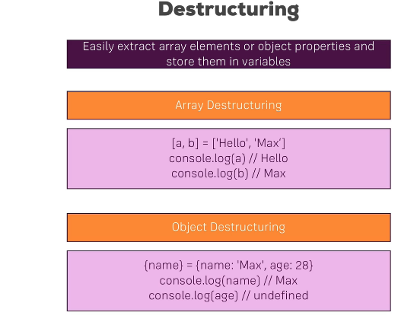

**Objects and Arrays are reference types. USE SPREAD OPERATOR TO ACTUALLY COPY THE OBJECT, Otherwise a pointer is used to write the value**

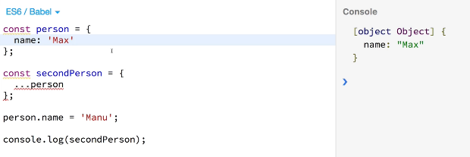

**Array functions example**

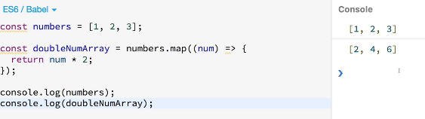

**REACT BASICS**

**Using a Build Workflow**

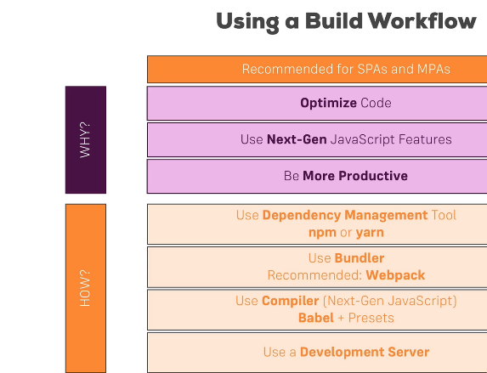

**Create a react app: need to download node.js from nodejs.org to use npm (node package manager)**

[**https://github.com/facebook/create-react-app**](https://github.com/facebook/create-react-app)

**usin cmd/terminal (-g to provide access globally)**

rakesh:desktop madhulikarakesh$ sudo npm install create-react-app –g

Create a new react app names ‘react-complete-guide’

rakesh:react madhulikarakesh$ create-react-app react-complete-guide --scripts-version 1.1.5

render and return are very important to return the html

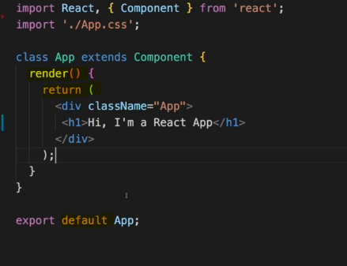

**Use className instead of class in JSX for css.**

**Creating a functional component:**

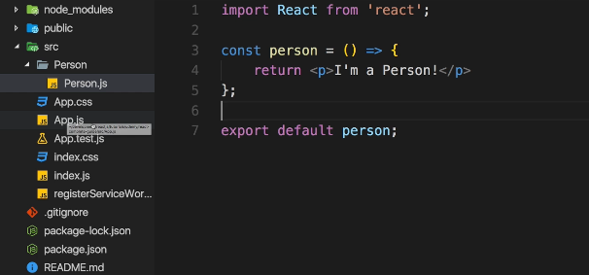

**using in root component, always use Uppercase for component names**

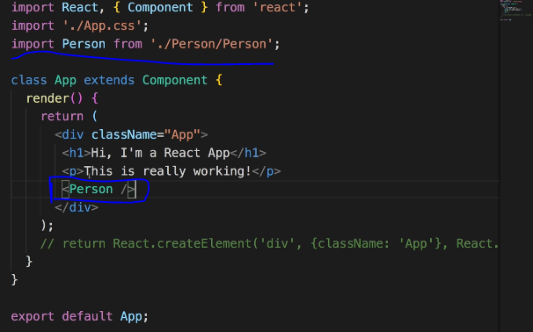

Summary of JSX:

Components are the **core building block of React apps**.

A typical React app therefore could be depicted as a **component tree** - having one root component ("App") and then an potentially infinite amount of nested child components.

Each component needs to return/ render some **JSX** code - it defines which HTML code React should render to the real DOM in the end.

**JSX is NOT HTML** but it looks a lot like it. Differences can be seen when looking closely though (for example className in JSX vs class in "normal HTML"). JSX is just syntactic sugar for JavaScript, allowing you to write HTMLish code instead of nested React.createElement(...) calls.

When creating components, you have the choice between**two different ways:**

1. **Functional components** (also referred to as "presentational", "dumb" or "stateless" components - more about this later in the course) => const cmp = () => { return <div>some JSX</div> } (using ES6 arrow functions as shown here is recommended but optional)
2. **class-based components** (also referred to as "containers", "smart" or "stateful" components) => class Cmp extends Component { render () { return <div>some JSX</div> } }

Use single curly braces to output dynamic content

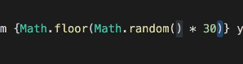

Passing dynamic content as props

In the class:

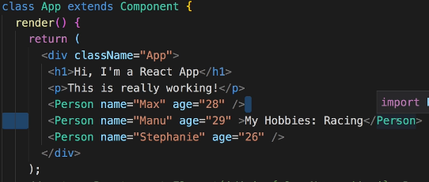

**In the reusable component:**

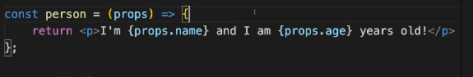

**Using Children prop: ‘children’ refers to any elements within the opening and closing tag of the component. This can be any html text or other react component.**

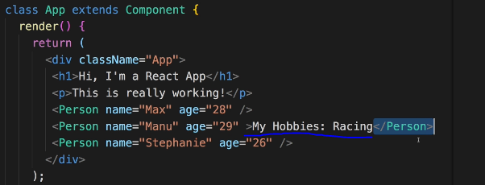

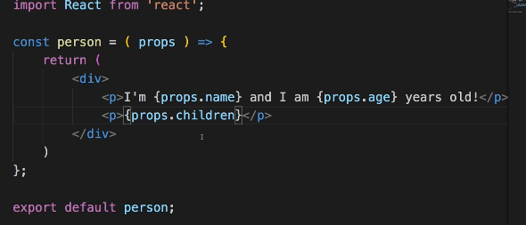

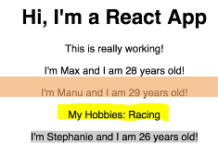

**In components that extends components only – u can create a state property to manage component internal data.**

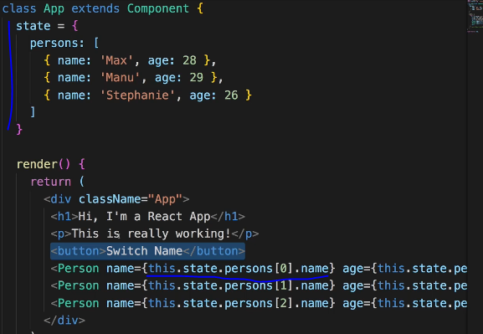

**Props & State**

props and state are CORE concepts of React. Actually, only changes in props and/ or state trigger React to re-render your components and potentially update the DOM in the browser (a detailed look at how React checks whether to really touch the real DOM is provided in section 6).

**Props**

props allow you to pass data from a parent (wrapping) component to a child (embedded) component.

Example:

AllPosts Component:

const posts = () => {

return (

<div>

<Post title="My first Post" />

</div>

);

}

Here, title is the custom property (prop ) set up on the custom Post component. We basically replicate the default HTML attribute behavior we already know (e.g. <input type="text"> informs the browser about how to handle that input).

Post Component:

const post = (props) => {

return (

<div>

<h1>{props.title}</h1>

</div>

);

}

The Post component receives the props argument. You can of course name this argument whatever you want - it's your function definition, React doesn't care! But React will pass one argument to your component function => An object, which contains all properties you set up on <Post ... /> .

{props.title} then dynamically outputs the title property of the props object - which is available since we set the title property inside AllPosts component (see above).

**State**

Whilst props allow you to pass data down the component tree (and hence trigger an UI update), state is used to change the component, well, state from within. Changes to state also trigger an UI update.

Example:

NewPost Component:

class NewPost extends Component { // state can only be accessed in class-based components!

state = {

counter: 1

};

render () { // Needs to be implemented in class-based components! Needs to return some JSX!

return (

<div>{this.state.counter}</div>

);

}

}

Here, the NewPost component contains state . Only class-based components can define and use state . You can of course pass the state down to functional components, but these then can't directly edit it.

state simply is a property of the component class, you have to call it state though - the name is not optional. You can then access it via this.state in your class JSX code (which you return in the required render() method).

Whenever state changes (taught over the next lectures), the component will re-render and reflect the new state. The difference to props is, that this happens within one and the same component - you don't receive new data (props ) from outside!

Button onClick event handler: make sure to use ‘C’ as uppercase in onClick event

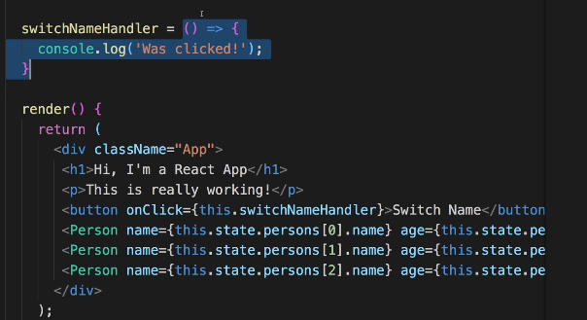

List of supported events:

<https://reactjs.org/docs/events.html#supported-events>

this.setState to update the state of the react DOM. Will only overwrite the requested part, instead of all the state.

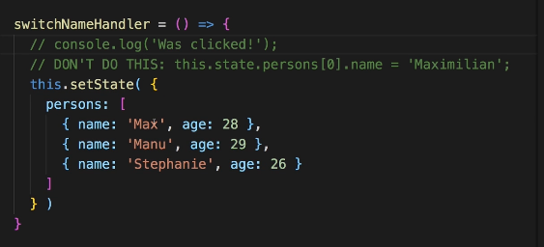

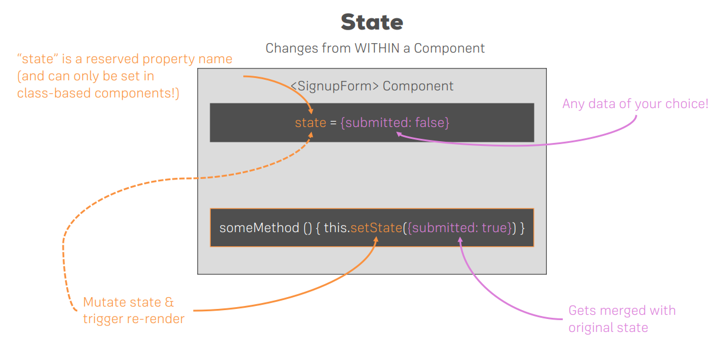

Using React Hooks:

**useState** is the most important recat hooks : Used in place of component in the import header

using functional components instead of class based react components using hooks.

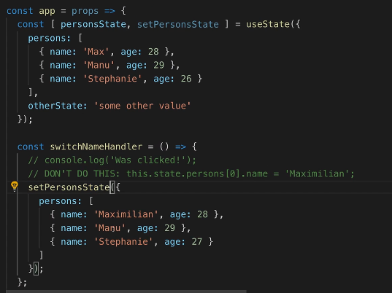

New state will overwrite the old state data, so make sure to manually add the old state data as well

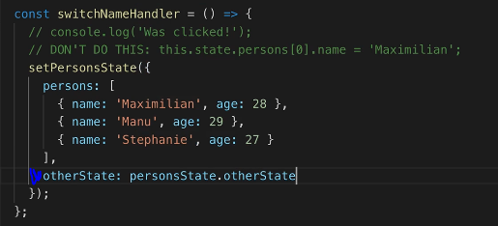

OR create multiple states instead of one single state

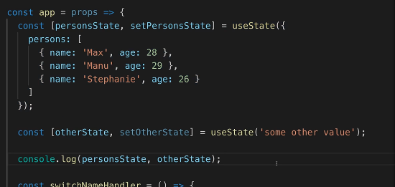

Have as many stateless components and fewer stateful components to avoid issues with maintaining states in multiple places.

Passing method references between components:

In class

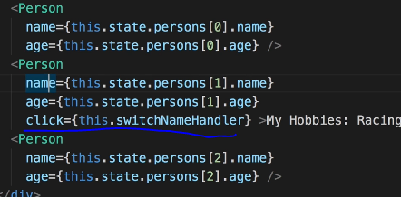

In component:

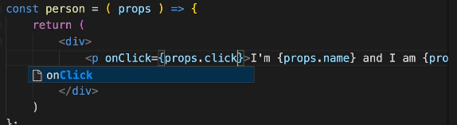

Passing values as arguments to handlers:

Using bind – preferred way

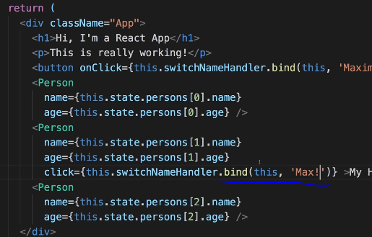

Using arrow function: not much efficient

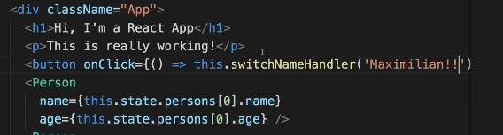

Two way binding

In the class: write a new event handler that accepts the event and can access the value from the event

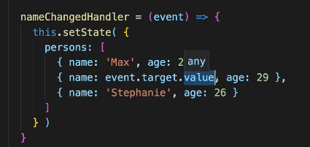

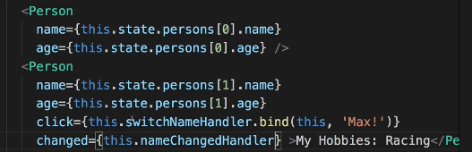

Within the component: accessing the event and also displaying the current value using value attribute. Without change event for a component in the class, the input will be readonly. In the above case, only one Person component has changed event, so only this will be mutable.

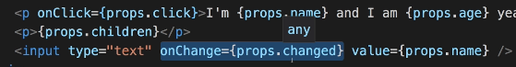

# Render Content Conditionally

Cannot use JavaScript if conditions inside the curly braces within the return block, one way is to just do a conditonal check as below. But this is not a good practice as it can become messy.

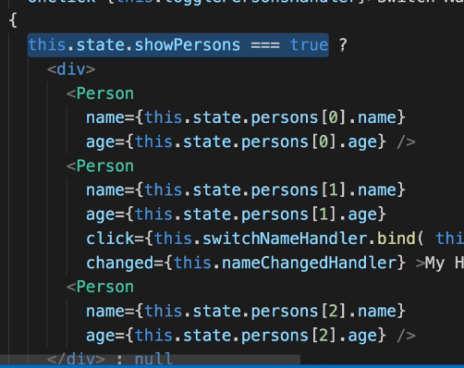

Since all the code inside render block will be executed by react, the ideal way is to create a variable and write a JavaScript condition check within render block before return and use that variable in the return block.

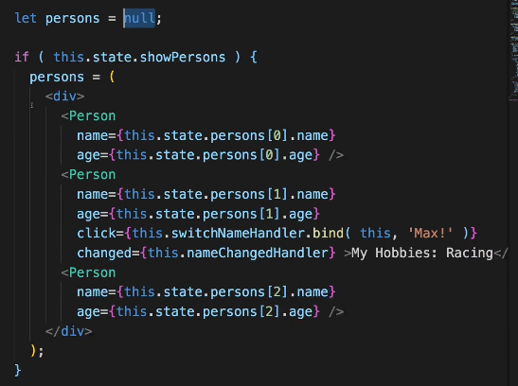

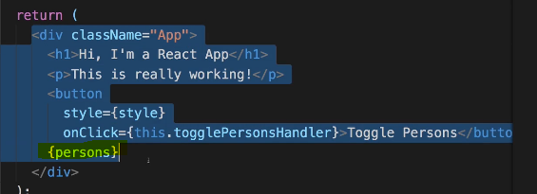

Outputting Lists using map keyword: mapping array

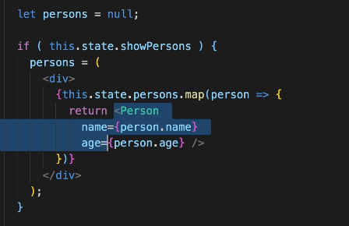

Deleting elements of the array; always update the state immutably without updating the actual object by creating a copy and work on that. Below screen uses, es6 spread operator to copy the elements of the users, delete one element with the index in the argument, and update the users with the new one.

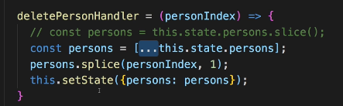

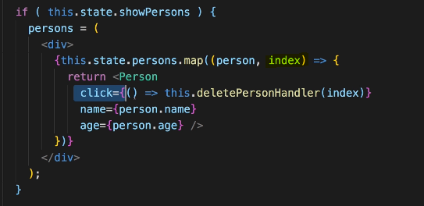

Use React ‘key’ (a unique id, which can be an id of every element in the database, or some unique value) property to efficiently track and rerender individual element of the list. Otherwise, react will just rerender every element which is not efficient when the application has large list of data to render and changes only made in one element.

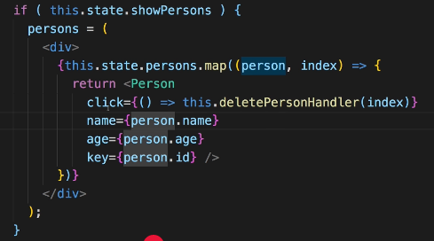

Javascript objects are reference types, so when try to copy the objects, always use spread operator, otherwise u get the pointer to the object. ALWAYS WORK WITH COPY OF OBJECTS.

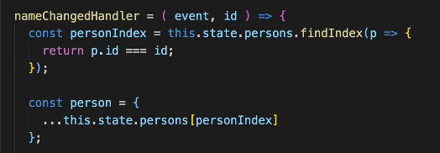

Below screen shows updating the list without mutating the state on ‘name’ change. Always work on the copies, not the actual object.

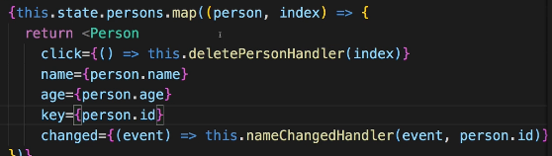

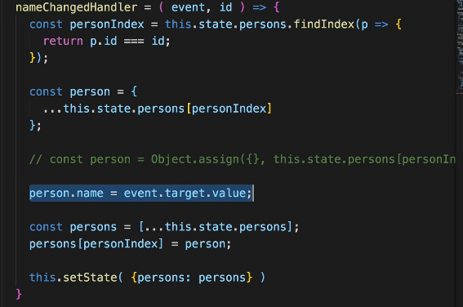

Lists and keys references:

<https://reactjs.org/docs/lists-and-keys.html>

# Styling React components:

Styling can be done in 2 ways:

1. inline styling: writing styles within the components and applied to only that component
2. css files: writing stylesheets and available globally

dynamically change styles:

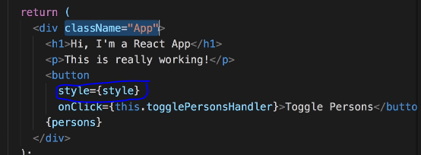

Writing inline style:

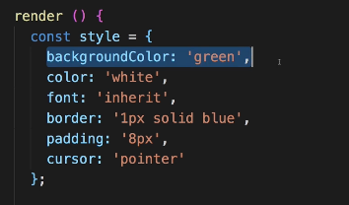

Change style based on a condition: everything is javascript, so can be conditionally handled

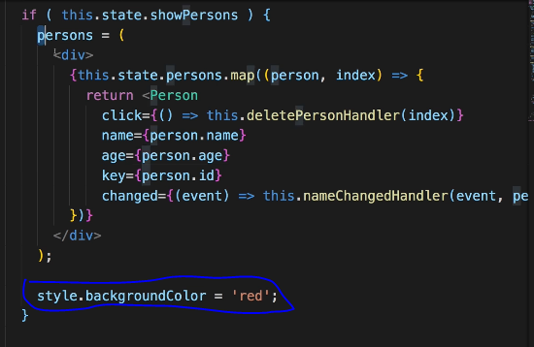

Adding classes dynamically:

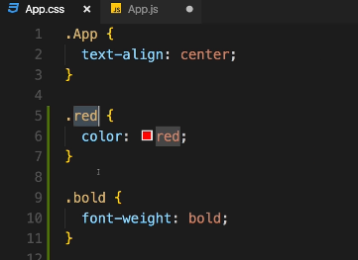

Within component: the array of strings will return as ’red bold’ for <p> tag

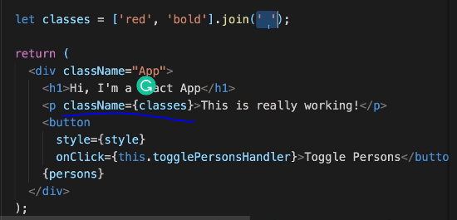

Dynamically apply classes and using join with an empty space to apply all styles in the array.

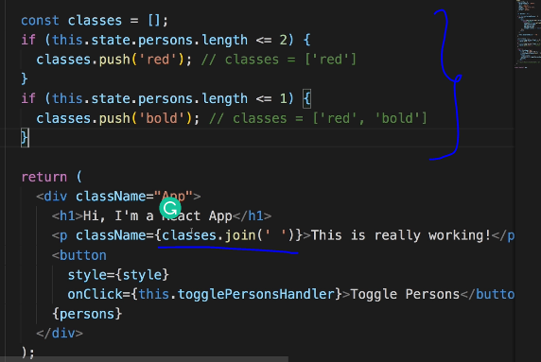

However, the problem with inline styling is cannot apply pseudo selectors, has to be written in css stylesheets. For example if u want to apply hover (button:hover) that cannot be done.

Using third party package Radium to achieve that. **Radium** is a popular package for react which allows to use inline styles with pseudo selectors and media queries

npm install –save radium

After installation, make sure to import Radium in the component.

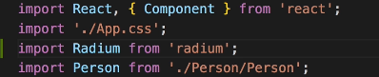

And wrap the component using radium

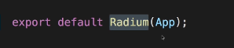

Update in the style

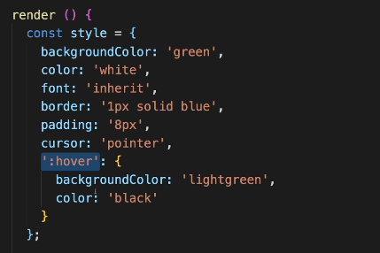

conditional update within the if statement:

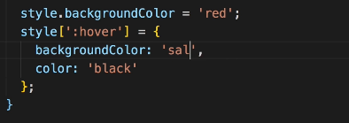

To write media queries using radium, need to import StyleRoot and wrap the whole div with Styleroot:

Writing media query in style variable below and use it in the div. this style will overwrite className which is default css functionality.

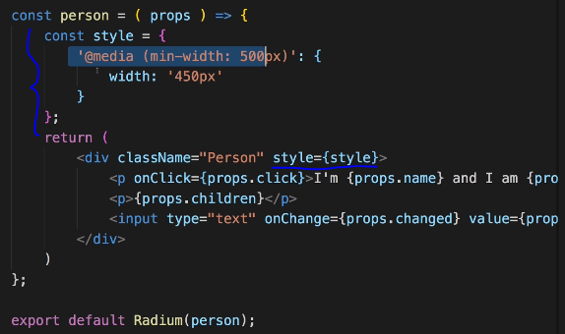

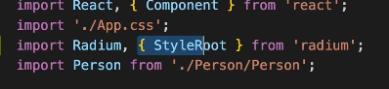

Wrap everything in Styleroot

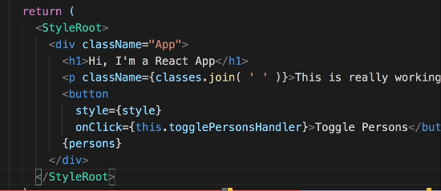

Styled Components Library: other library popular similar to radium

<https://styled-components.com/>

npm install --save styled-components

move all the css between styled components

first import



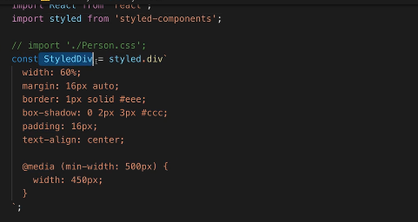

Use this as div

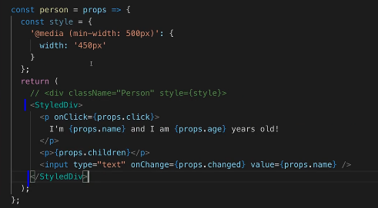

Dynamically changing properties of styledcomponents

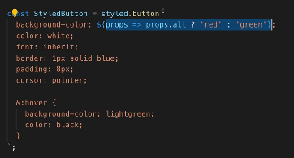

Just add any property (‘alt’ here)

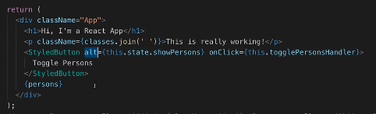

RADIUM AND STYLED COMPONENTS MIGHT MAKE JS CODE BLOATED. INSTEAD USE CSS MODULES TO KEEP JS AND CSS SEPARATE.

To use css modules:

1. UPDATE *.css file name to *.module.css (from person.css to person.module.css)
2. Import the css as : import classes from ‘./person/person.module.css’

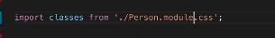

1. Using the property as : <div className={classes.Person}/> (Person is the css in the person.module.css)

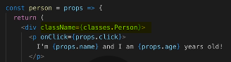

1. To dynamically change the style, just DO AS BELOW

if(this.state.users.length <=2)

classesLst.push(classes.red);

if(this.state.users.length <=1)

classesLst.push(classes.bold);

References for css modules:

<https://github.com/css-modules/css-modules>

# Debugging React Apps

Add React developer tools extension in chrome. Will be part of developer tools.

Use **Error Boundaries** when you need to handle errors in react js. Only use when we know something could fail and can’t control that, not every single time.

Note: Only displays the result of error boundary in deployment server, not in development server.

Usage:

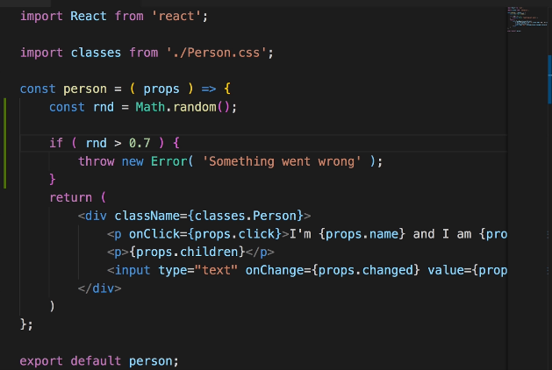

Create a ErrorBoundary class (name can be anything)

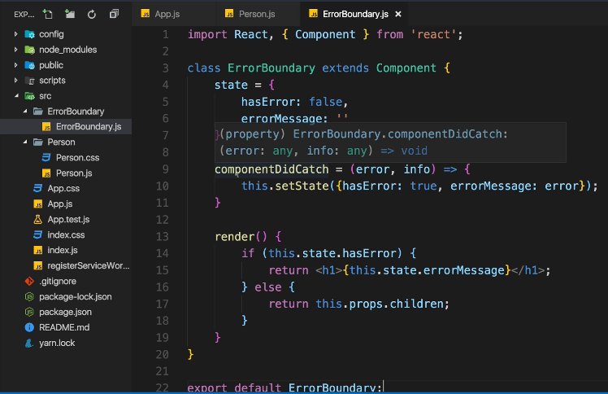

Usage in component:

First import the error boundary on the top of the class component, then wrap the div inside this errorboundary. Make sure to move the key property to top for mapping.

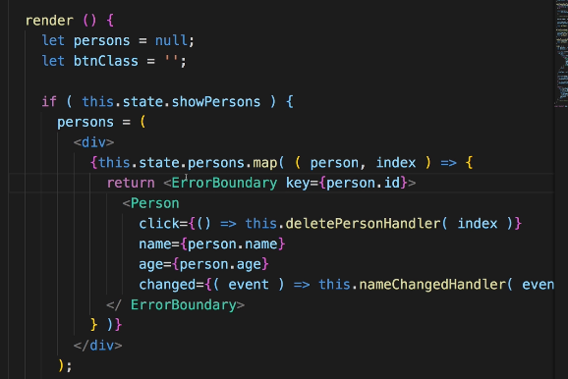

Error boundary Reference:

<https://reactjs.org/docs/error-boundaries.html>

More on Components:

Better project structure:

Move all components under one folder

Move all assets under one folder

Move main class files under Containers folder

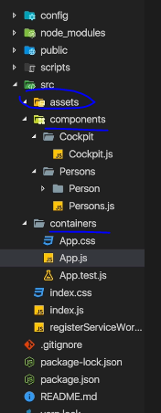

Best practice to have class based components for state management, and functional components for presentation

Have the project structure by outsourcing the granular functionalities.

Example: change below screen to next couple screens:

Screen 1 without any update

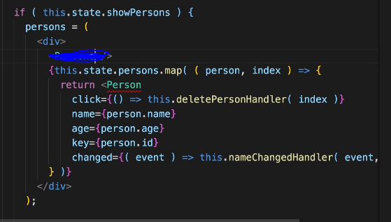

Screens after updating the structure by outsourcing the persons logic

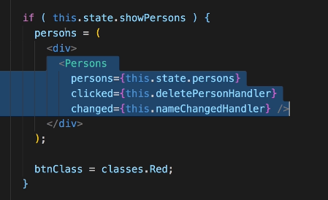

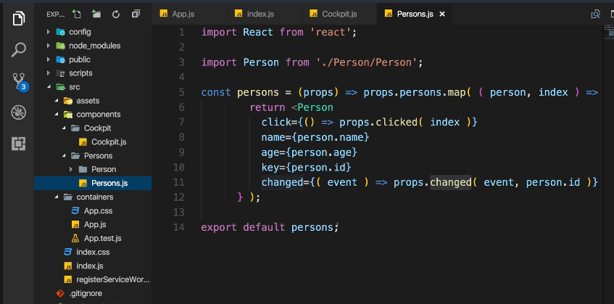

Use as many functional components as possible and maintain lean containers.

Class based vs functional components: access to state in functional components is only available after version of react>16

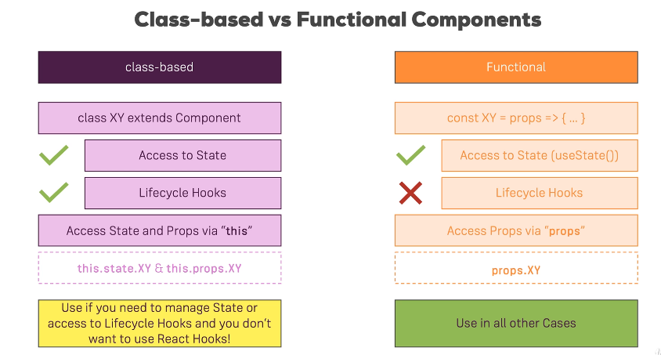

Usage off this.props: Within index.js we can pass properties and access it anywhere within the class as this.props and can be passed to functional components.

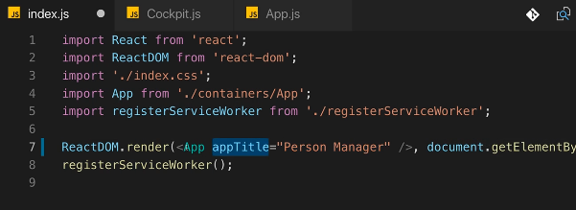

Within class based component:

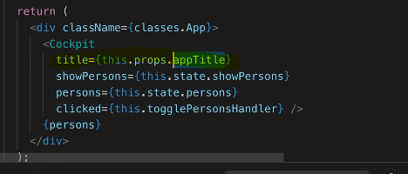

In the functional component:

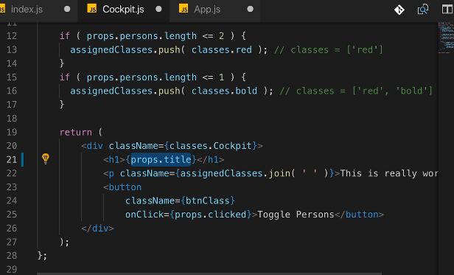

Component life cycle**:**

only available for class based component, while, functional components have an equivalent one

Methods available in any class based component:

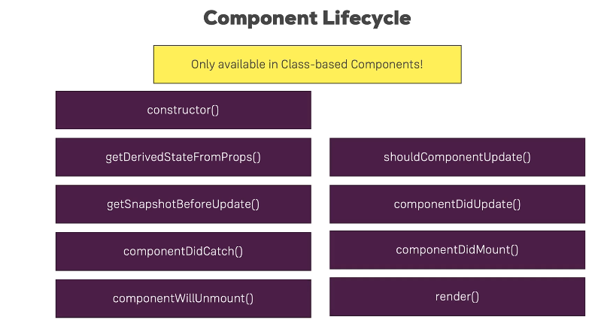

Create lifecycle

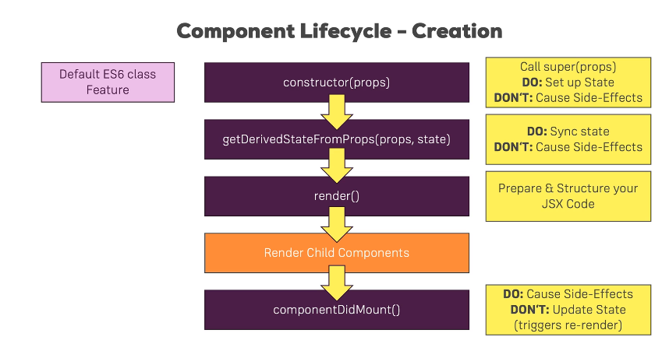

Example of workflow in a classbased component:

1. Adding constructor with props and calling super(props) which will call the parent class constructor and make any necessary initializations. Int this case it will initialize the constructor in the Component class which this class extends

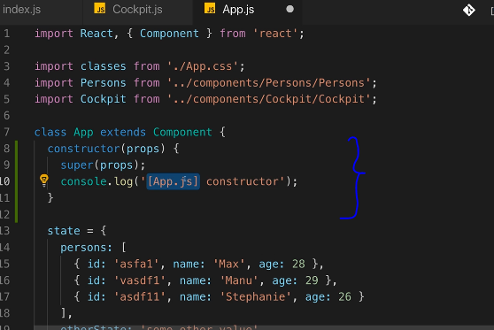

State in the above screen can alaso be initialized within the constructor, with the new version of react>16 state can be initialized outside constructor.

1. Next, getderivedstatefromprops will be executed. Static keyword is important and must for react to execute this properly.

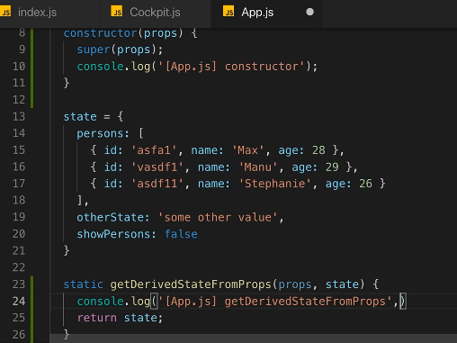

1. Next, render will be executed
2. Now child components will be rendered.
3. Next, componentDidMount will run, which allows us to make http requests

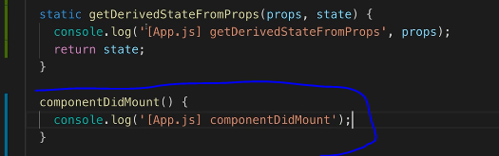

Update lifecycle

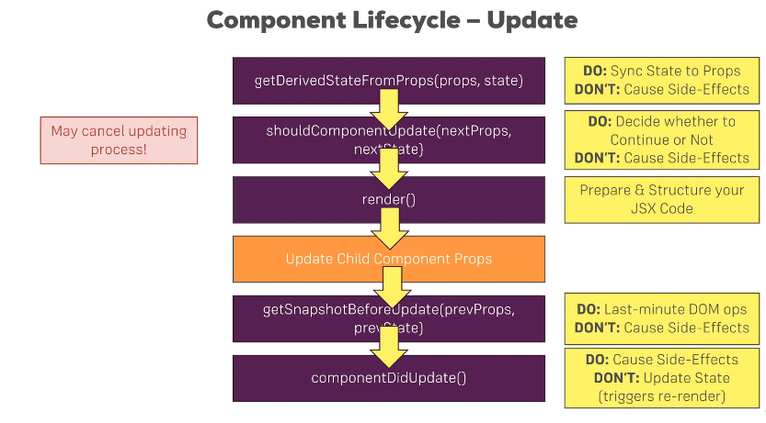

Example:

1. getDerivedStateFromProps will be called

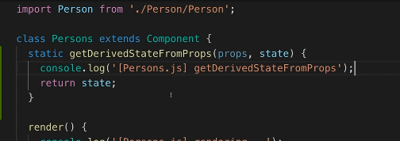

1. ShouldComponentUpdate follows, here conditional based check can be made

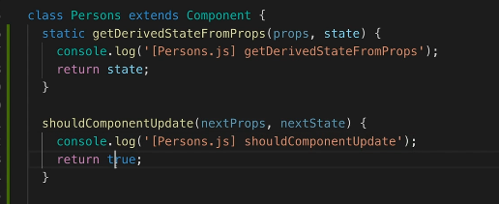

1. Render executes
2. Child components executes
3. getSnapshotbeforeupdate will be executed

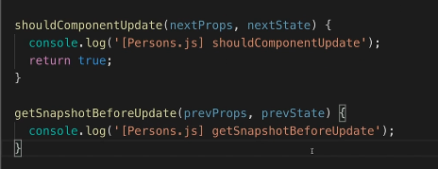

1. followed by Componentdidupdate

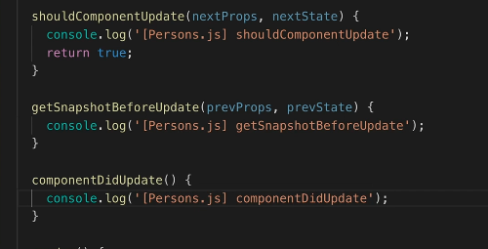

Using useEffect() in functional components

useState and useEffect are two most important hooks in react

Hooks – functions u can add into functional components

useEffect once imported, can be added to a functional component and will run for every render cycle. We can use any number of useEffect in a functional component.

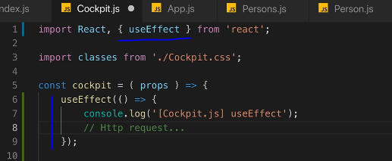

Any http requests can be made here within useEffect, as this executes for every render. It combines ComponentDidMount and ComponentDidUpdate events in class based components.

To only execute useEffect when there is a change in an array we need to explicitly specify a second argument in useEffect as below. The second argument can also be an empty array.

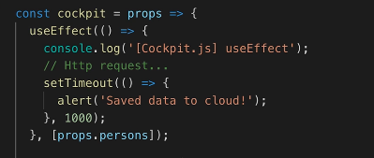

When passing an empty array, the userEffect only runs once on the first render. The empty array tells react that this effect has are no dependencies and so useEffect will not run again.

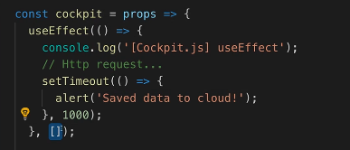

To Clean up or to execute something before component is being removed, then use ComponentWillMount in class based component

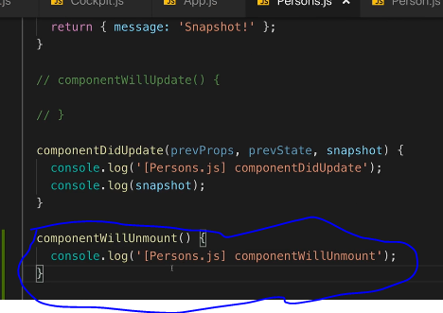

To do the cleanup work in functional component- return in useEffect

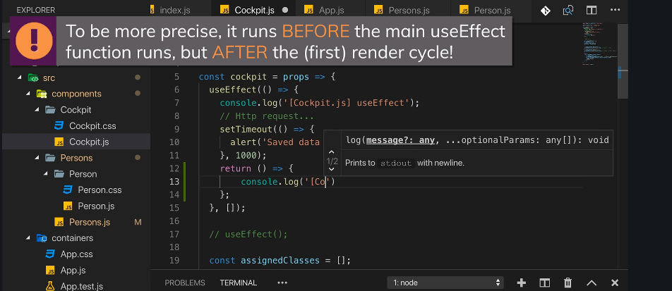

useEffect can be run either when the component gets destroyed (by passing an empty array as the second arguent in useEffect) or when passing without any second argument to useEffect which will run on every update cycle or when passing a valid array which will then useeffect on every time the array changes.

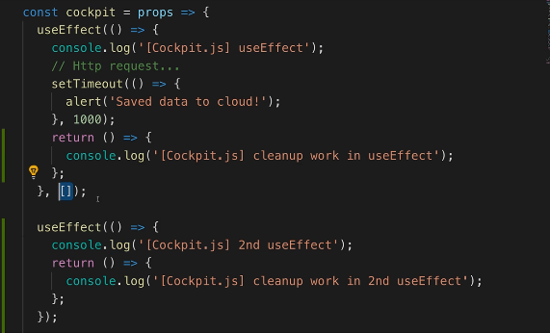

To render any class based component only if there is a change in the object/array then can be done in shouldcomponentupdate as below

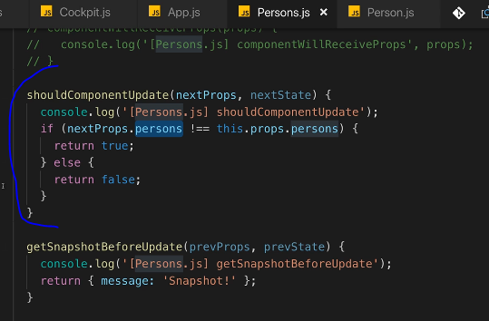

To optimize functional components- use React.memo() (wrap the component )

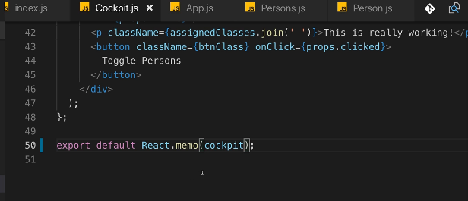

Use PureComponent to check if any prop changed, instead of writing conditions to check for every property changed. It is a normal component that checks for all the prop checks, so instead of using shouldcomponentupdate with all the props changed check, just use purecomponent.

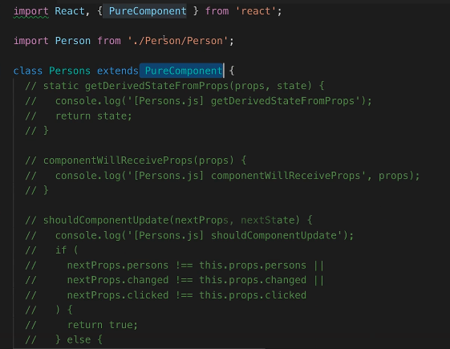

HOW REACT UPDATED THE DOM

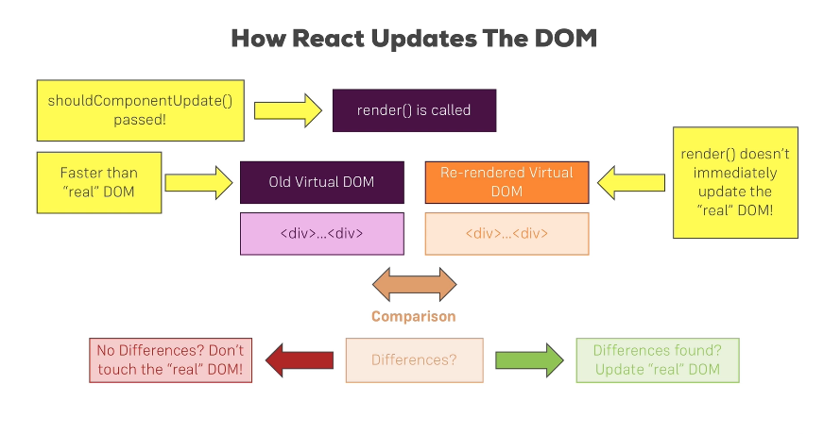

Rendering adjacent JSX elements:

Not possible to render multiple root elements in a jsx file, so one option is to render an ayyar object with multiple elements in it, which is not an optimal way when displaying jsx elemnts. The other way os creating a wrapper and displaying all the children in it.

Hoc-higher order component

Aux- use Aux in mac/linux but in windows use Auxiliary as aux is a reserved word in windows

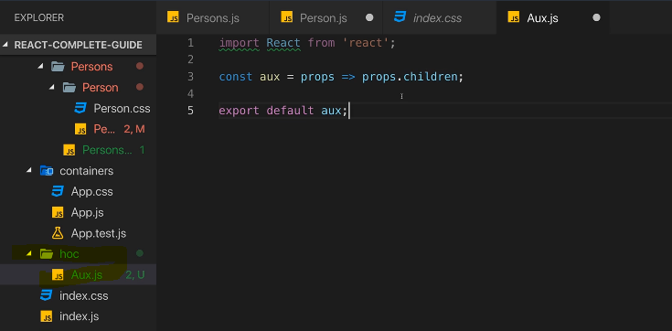

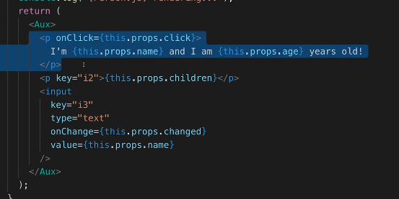

React>16 has in build aux functionality, can be done using React.Fragment as below

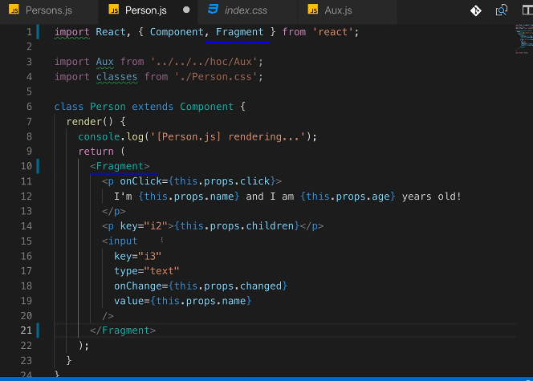

Another example of writing hoc with class:

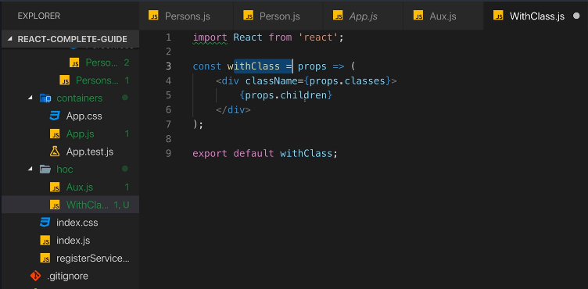

Another form of using hoc: passing functional component and classnames and other parameters as below:

withClass component:

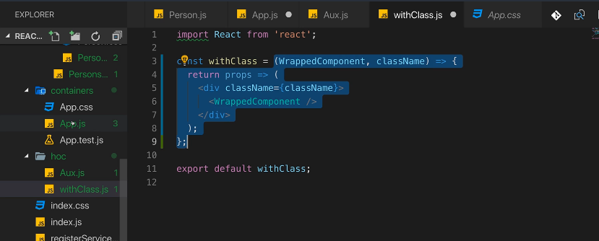

Usage in classbased/ functional component:

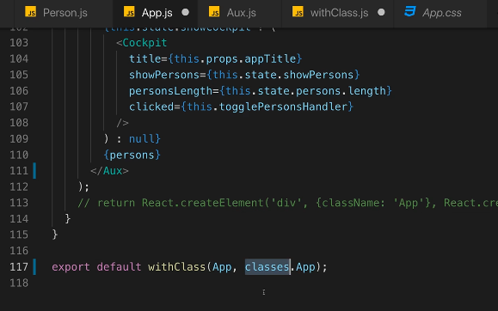

Changing State correctly: better way /good practice to use prev state as below when depending on old state (below example where counter is incremented)

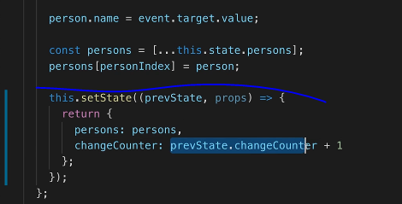

Define prop types for displaying type of the properties and other information: using proptypes package to enforce proper prop types.

Npm install –save prop-types

Usage:

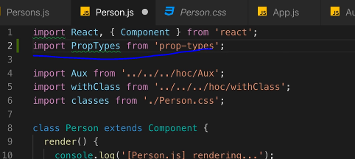

Now add the property types:

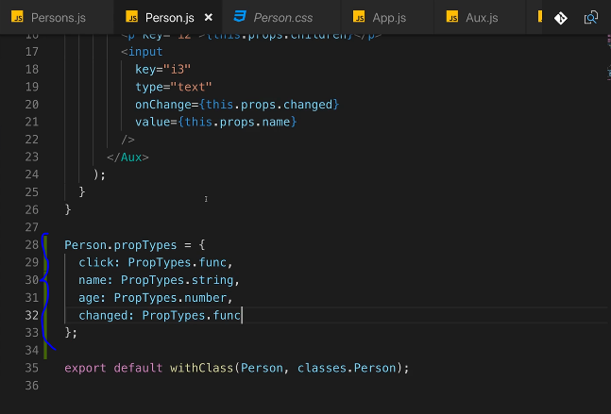

Using Refs: to highlight a specific field or focus a field upon render.

Two ways: one way is without using createRef and one without

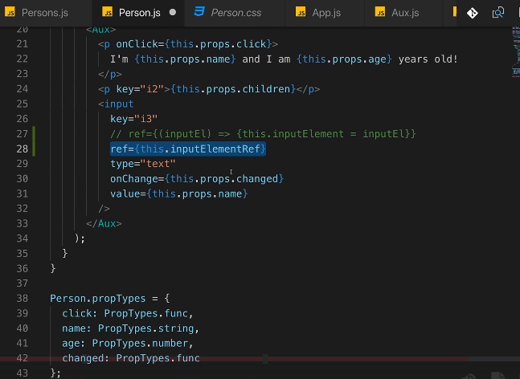

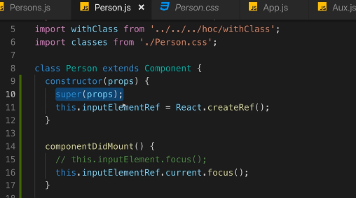

For functional components use react hook useRef as below. Make sure to call the button click after render, that is, in useEffect, which runs after render cycle (see screen 3 below).

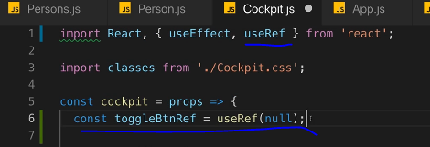

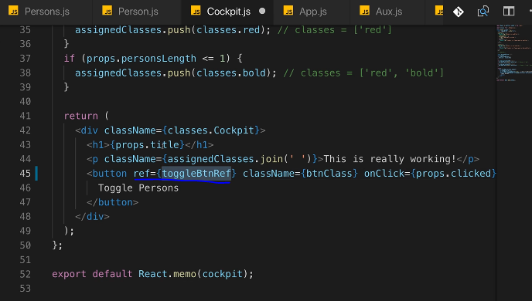

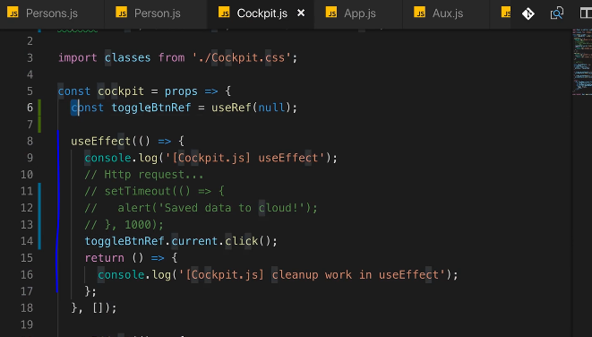

Using the contextAPI: Useful when passing very long chains of data and you don’t want to pass data from component to component to another component and if that data is not needed in between components. Context is the great way of bypassing the components and passing data directly from one component to another component.

useContext() hook in react can be used in functional components vs static contextType in class based component.

Plan a React Application:

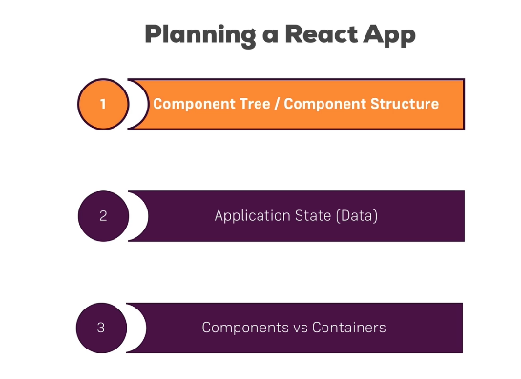

Application layout

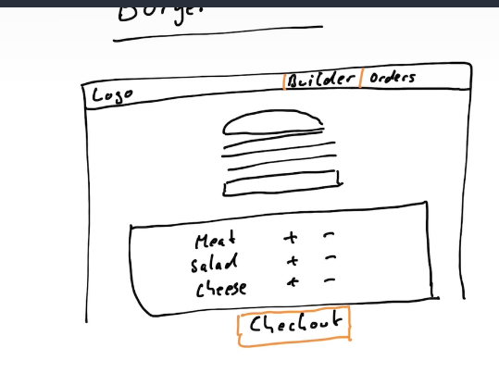

Components needed:

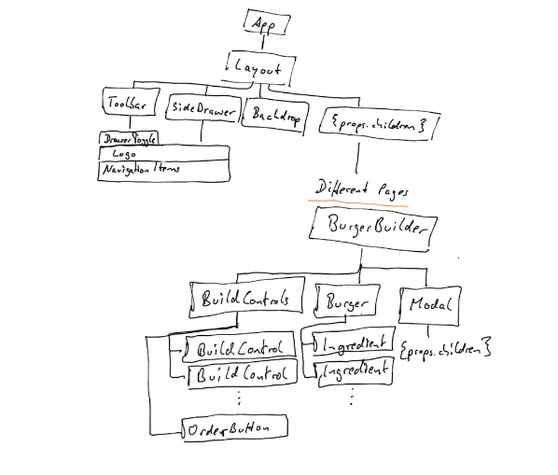

Planning the state:

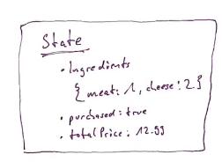

State can be maintained in the app component but it makes more sense to have it in the BurgerBuilder component because that is where all the burger related activity happens. So, burgerBuilder will be a stateful component. All other components can be stateless components

# AXIOS

Package to make http requests. Using jsonplaceholder here for dummy http requests/data

npm install axios –save

Make requests in ComponentDidMount. Asynchronously perform requests, so this implements promises which mean get uses promise then which gets executed when then data is returned back from the request

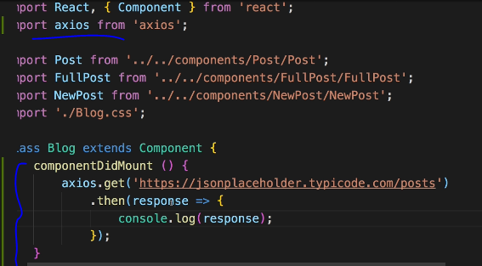

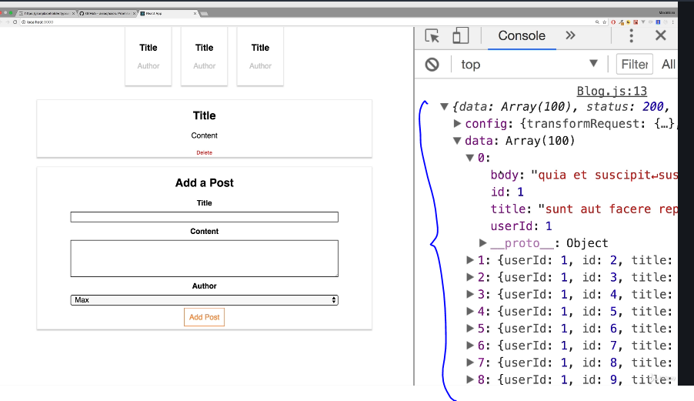

One example of data transformation after data get

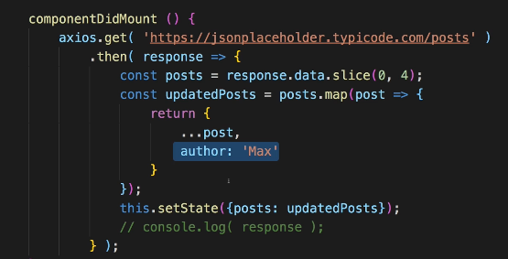

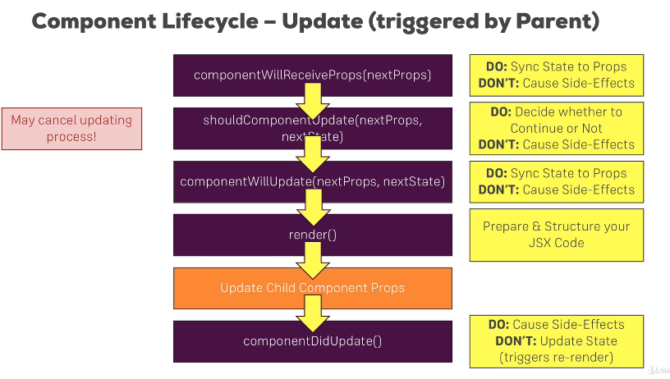

Infinite loop in componentdidupdate below: setstate will call the same method again and again.

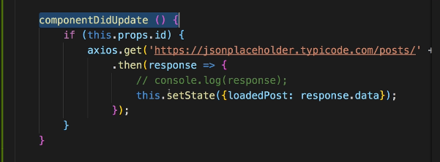

Inorder to avoid infinite loop add a condition to make a get call only upon a change in the request id as below, and also check for not null loadedPost data

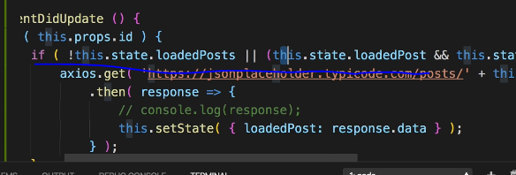

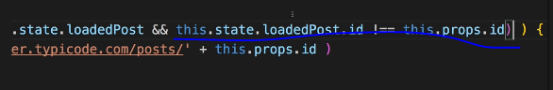

Axios POST EXAMPLE: Takes a js object and the data is sent in json format

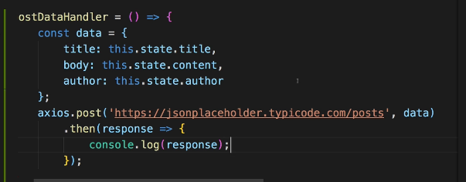

AXIOS delete example

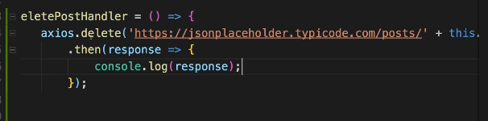

Catch error in axios calls using catch

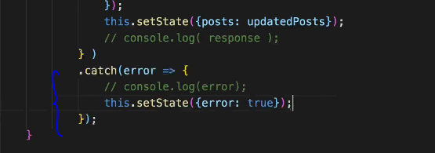

And load page content based on the error

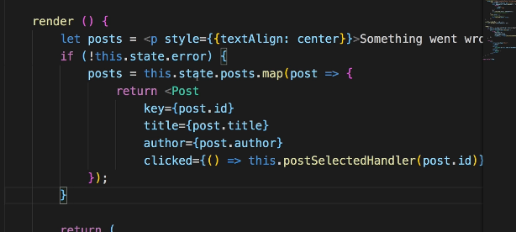

# Interceptors

Add Interceptors to Execute code globally.

For example, to globally execute any method globally on axios get/post/delete calls.

Interceptors are functions that will be executed globally upon every request leaving the app or upon every response returning to the app.

Examples: to set authorization headers, to log responses or log errors globally.

Below screen shows the interceptors added to index.js (parent page) where the application root element is created.

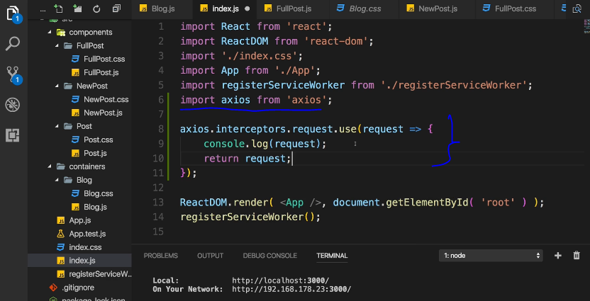

We can also pass another function, error to log any errors globally and return the promise.reject to continue the call and to be able to handle the error locally in the catch block of the request as well.

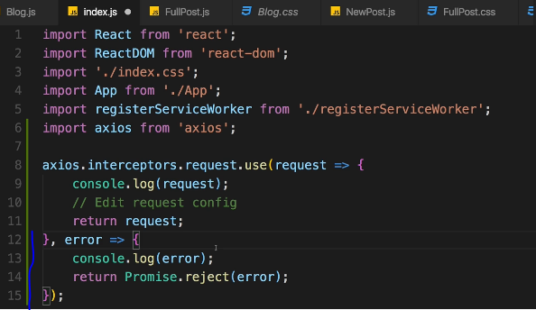

To handle responses for globally manipulating the responses or logging them:

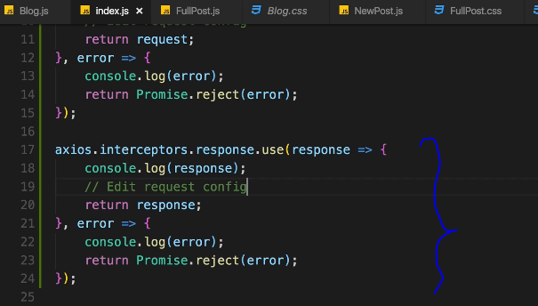

Removing Interceptors

getting rid of one is also easy. Simply store the reference to the interceptor in a variable and call eject  with that reference as an argument, to remove it (more info: <https://github.com/axios/axios#interceptors>):

var myInterceptor = axios.interceptors.request.use(function () {/*...*/});

axios.interceptors.request.eject(myInterceptor);

Setting a default global configuration:

To set a default base url for every request as below

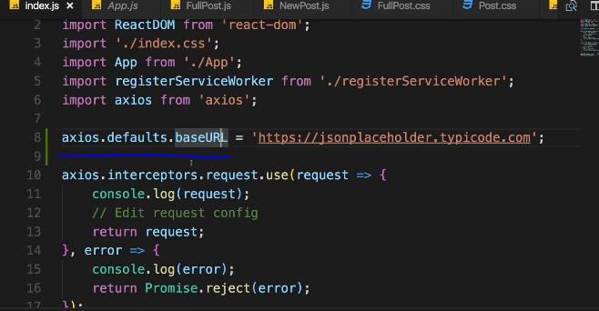

Now, the base url is default appended to every request:

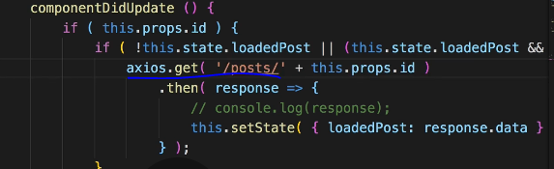

Other examples: setting default configurations that can be used application wide.

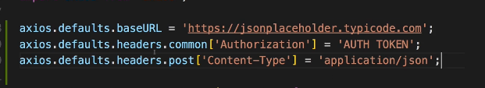

Creating and using AXIOS instances

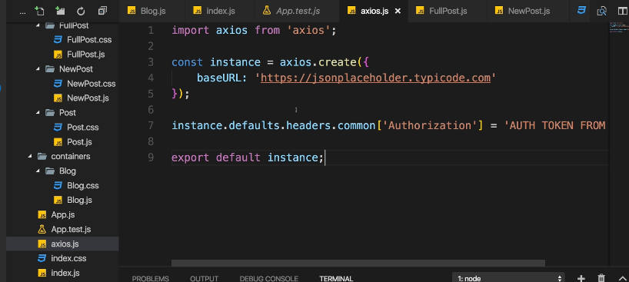

TO USE THIS instance specific file, just use as below, instead of global in any file. These settings will overwrite global settings

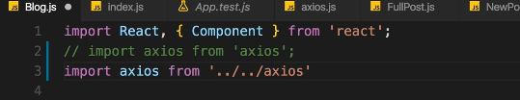

# Routing

Need routing package. Install react-router-dom (for react to be able to render the routing to dom)

1. npm install –save react-router-dom
2. Upon successful installation, to use it in the application, the app need to be wrapped in the router as below. Once wrapped, any sub component that is inside the BrowserRouter can now use routing features (ex: history props)

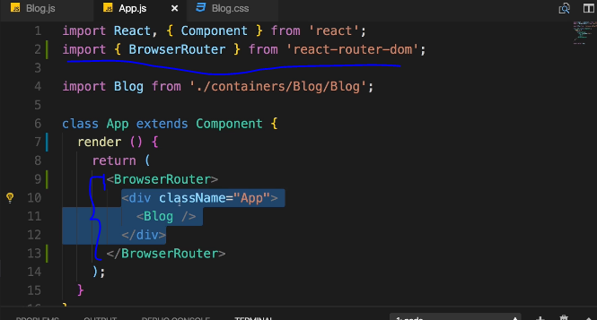

1. import Route and NavLink ( replaces Link tag doesn’t give active class, and anchor tag which will refresh the whole page and state is not retained) in the component where routing has to happen

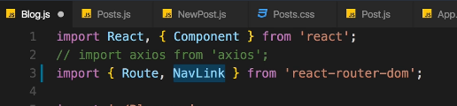

1. usage within the component: add NavLink section and their corresponsing routes underneath as seen below:

In below screens, Route can be defined with exact or without exact, default value of exact is false when not specified. When exact is specified, the route/url will strictly check for the path specified. In below case Home header (from first Route) will only be seen when clicked on the Home link (first li tag). With exact not specified, Home 2 header will be shown in every page that has the prefix ‘/’ which is both the pages in below case

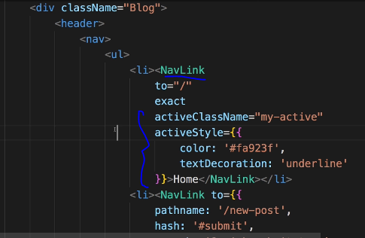

NavLink can be used to pass some query params and hash fragment (move to this hash fragment) added to url. Using NavLink instead of Link will allow to pass dynamic css using activeClassName and activestyle(inline style). Also, use exact to apply styles to home page with just ‘/’, otherwise styles apply to any route that has prefix specified in ‘to’.

Below is the URL after route implementation with parameters

http://localhost:3000/**new-post?quick-submit=true#submit**

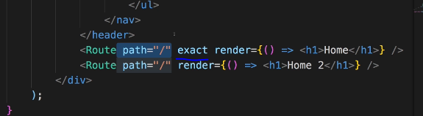

Render in the above Route is usually used for any message displays only, can still write whole component code but that only messes up the coding. Instead, to load a component just use the below way. Posts and NewPost in below code is the imported component name.

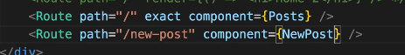

this.props can be used in in componentdidmount (upon every render) to check for exact match or to route to another url without use of Link again (more on this later).

To pass on the router props to child components, can use withRouter as below:

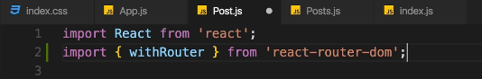

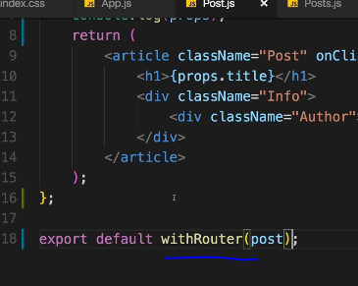

.The path you can use in to can be either **absolute** or **relative**.

#### **Absolute Paths**

By default, if you just enter to="/some-path"  or to="some-path" , that's an **absolute path**.

**Absolute path** means that it's**always appended right after your domain**. Therefore, both syntaxes (with and without leading slash) lead to example.com/some-path .

#### **Relative Paths**

Sometimes, you might want to create a relative path instead. This is especially useful, if your component is already loaded given a specific path (e.g. posts ) and you then want to append something to that existing path (so that you, for example, get /posts/new ).

If you're on a component loaded via /posts , to="new"  would lead to example.com/new , **NOT** example.com/posts/new .

To change this behavior, you have to find out which path you're on and add the new fragment to that existing path. You can do that with the url  property of props.match :

<Link to={props.match.url + '/new'}>  will lead to example.com/posts/new  when placing this link in a component loaded on /posts . If you'd use the same <Link>  in a component loaded via /all-posts , the link would point to /all-posts/new .

**There's no better or worse way of creating Link paths** - choose the one you need. Sometimes, you want to ensure that you always load the same path, no matter on which path you already are => Use absolute paths in this scenario.

Use relative paths if you want to navigate relative to your existing path.

### Parsing Query Parameters & the Fragment

To extract route parameters (=> :id etc).

But how do you extract search (also referred to as "query") parameters (=> ?something=somevalue at the end of the URL)? How do you extract the fragment (=> #something at the end of the URL)?

Query Params:

You can pass them easily like this:

<Link to="/my-path?start=5">Go to Start</Link>

or

<Link

to={‌{

pathname: '/my-path',

search: '?start=5'

}}

>Go to Start</Link>

React router makes it easy to get access to the search string: props.location.search .

But that will only give you something like ?start=5

You probably want to get the key-value pair, without the ? and the = . Here's a snippet which allows you to easily extract that information:

componentDidMount() {

const query = new URLSearchParams(this.props.location.search);

for (let param of query.entries()) {

console.log(param); // yields ['start', '5']

}

}

URLSearchParams is a built-in object, shipping with vanilla JavaScript. It returns an object, which exposes the entries() method. entries() returns an Iterator - basically a construct which can be used in a for...of... loop (as shown above).

When looping through query.entries() , you get arrays where the first element is the key name (e.g. start ) and the second element is the assigned value (e.g. 5 ).

Fragment:

You can pass it easily like this:

<Link to="/my-path#start-position">Go to Start</Link>

or

<Link

to={‌{

pathname: '/my-path',

hash: 'start-position'

}}

>Go to Start</Link>

React router makes it easy to extract the fragment. You can simply access props.location.hash .

Use Switch to load first found route. Just wrap all the elemnts with switch tag. This need to be imported from the react-router-dom

Import { Switch } from ‘react-router-dom’

<Switch>

<Route path="/" exact component={Posts}/>

<Route path="/new-post" exact component={NewPost}/>

<Route path="/:id" exact component={FullPost}/>

</Switch>

Navigating programmatically without using Link tag:

This can be achieved using history object we receive in the props.:

postClickedHandler=(id)=>{

this.setState({ selectedPostId: id });

//PROGRAMTICALLY NAVIGATE TO ANOTHER ROUTE

//this.props.history.push({pathname: '/' + id});

this.props.history.push('/' + id);

};

Use ComponentDidMount for initial loads and to perform any event related actions, use componentdidupdate to update the page when working with nested routes.

### Redirecting requests:

Use Redirect from react-router-dom package to redirect a url from one to other route. If using Redirect outside of a switch statement, cannot use from, just ‘to’ can be used.

Ex:

Import { Redirect } from ‘react-router-dom’

<Redirect from=’/’ to=’/posts’/>

Rediret can also done using history props as below:

this.props.history.replace('/posts')

Or

this.props.history.push('/posts')

The only diference is, if using push, the browser back arrow will take the user back to the last page. Using replace instead of push will replace the browser stack and will not take to last page.

To catch any routes that were not declared (404 error) use Route with render as below:

<Route render={() =><h1> Not fond</h1>}/>

This will not work with redirect, as they both catch errors or redirect to a route specified in the ‘to’

Code Splitter or Lazy Loading: Only loading portions of the application and loading the unused pages content only when loading them or when a user clicks on it.

Dynamically load components using asynccomponent. Refere to project blog.js and asynccomponent.js. Add that asynccomponent function inside route component lo load dynamically.

Lazy loading in react>16.6 using react Suspense

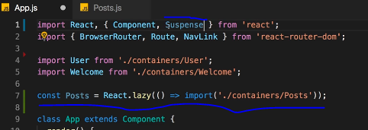

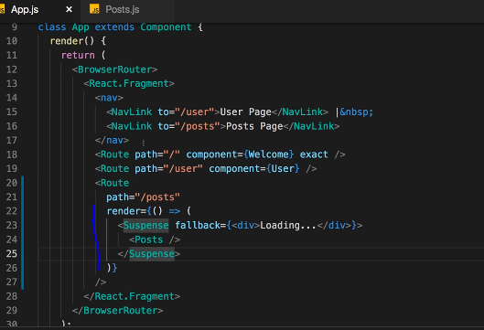

Other usage: load a component only upon a button click or upon a condition

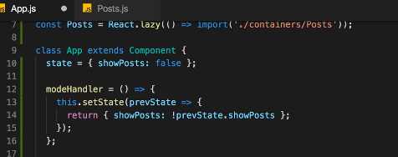

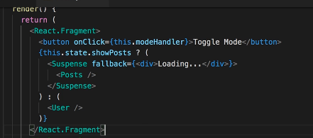

Router and Server deployment: Always handover the request to react app and let app take over the error handling.

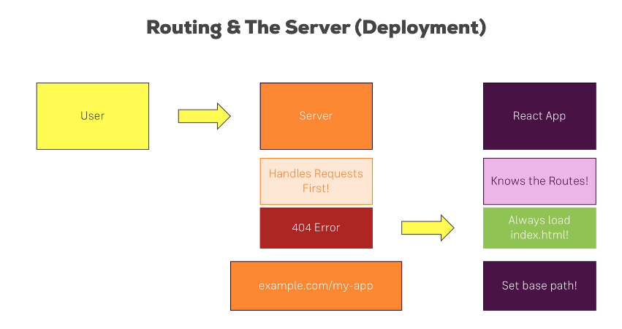

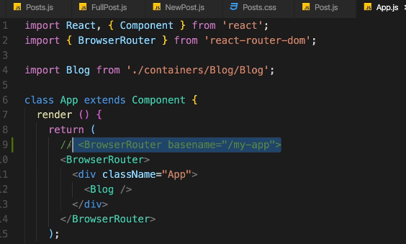

If application is using sub-directory set the basename in broswerRouter, otherwise the basename is by default ‘/’

# Form validation

Showing error messages:

The form inputs (<Input /> component) already receives the information whether it's invalid or not. You could of course easily add some conditionally rendered element inside of that component.

For example (inside <Input /> component function):

// all the other code from the videos

let validationError = null;

if (props.invalid && props.touched) {

validationError = <p>Please enter a valid value!</p>;

}

return (

<div className={classes.Input}>

<label className={classes.Label}>{props.label}</label>

{inputElement}

{validationError}

</div>

);

This could of course be finetuned. You could also pass the value type (e.g. "email address" ) as a prop:

validationError = <p>Please enter a valid {props.valueType}</p>;

You could also receive the complete error message as a prop:

validationError = <p>{props.errorMessage}</p>;

And of course, also don't forget to style the messages if you want to do that:

validationError = <p className={classes.ValidationError}>{props.errorMessage}</p>;

In your CSS file, you could have:

.ValidationError {

color: red;

margin: 5px 0;

}

Useful Resources & Links

Validate.js (you may import its functionality into your React projects):

<https://validatejs.org/>

Get more ideas about potential validation approaches:

<https://react.rocks/tag/Validation>

Alternatives to the manual approach taken in this course:

react-validation package:

<https://www.npmjs.com/package/react-validation>

formsy-react package:

<https://github.com/christianalfoni/formsy-react>

# Redux: State Management

State influences what you see on the screen. Some examples below

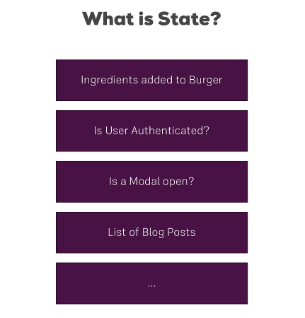

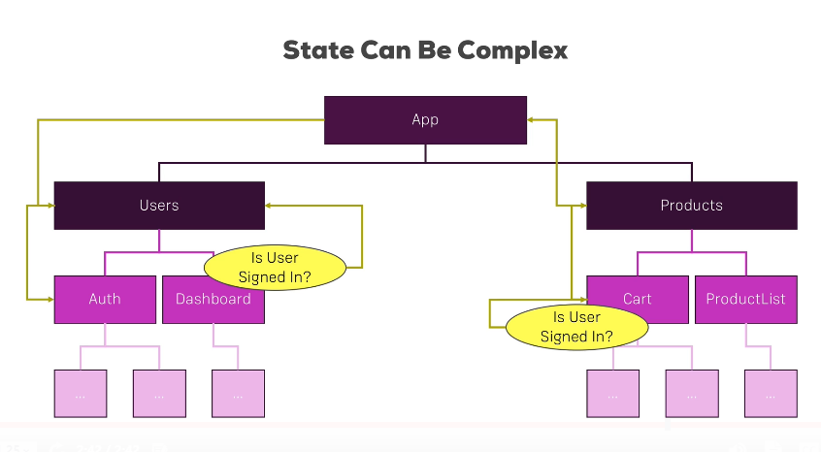

Redux is a third party library independent of react. It uses a central store(a javascript object) to store application state.

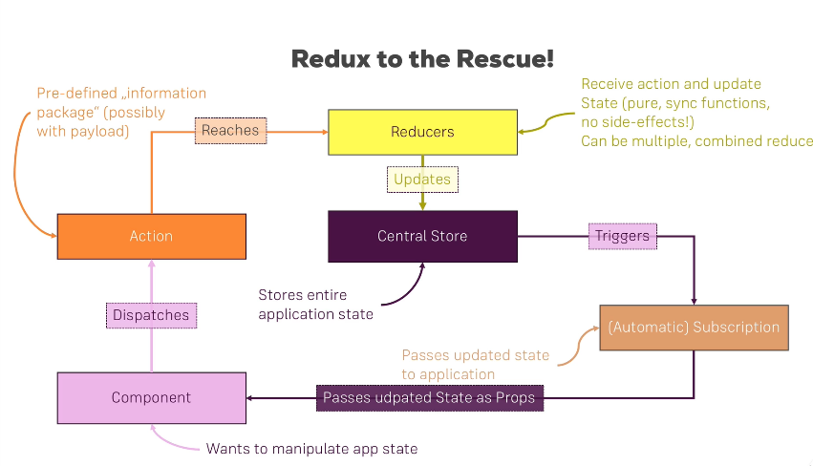

Install redux:

npm install –save redux

Redux basics:

Redux will use single store and only one reducer. So, in the below code a store is created with a rootReducer. The state can be a number or an object.

The below code uses node for initializations.

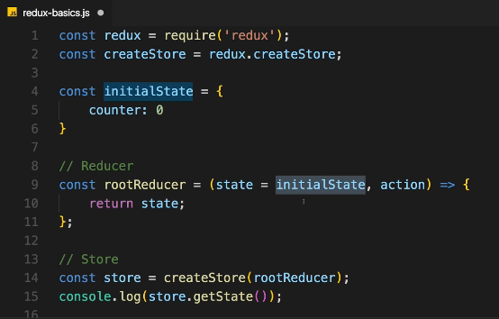

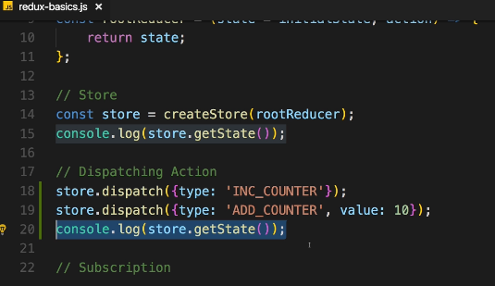

In dispatching action, the type is mandatory and can be any text all uppercase, and the value can be replaced by a javascript object. And, this actions need to be also handled in the reducer as below:

NEVER MUTATE ANY DATA. ALWAYS UPDATE IMMUTABLY. Copy the state properties first and then immutably update the counter as below.

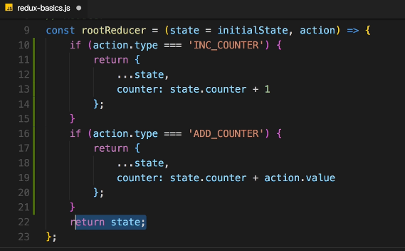

Subscriber: executed whenever there is a change in state or whenever the action reaches the reducer

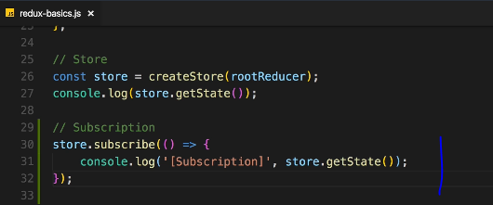

Connecting React to Redux:

1. Import createStore from redux in the root component.
2. Create a store folder, next to components and containers. This is where the reducer will be created. This is will be needed to create a store in the root component. (refer to below image)
3. Import reducer to the root component
4. Create a store with reducer

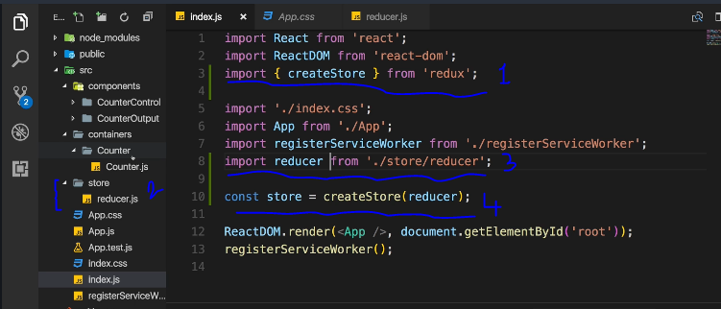

Code in reducer.js

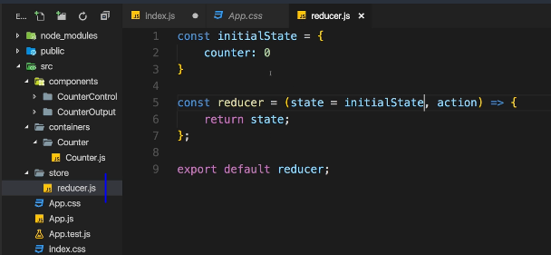

1. Connect redux to react, as redux is stand alone and not connected to redux. Install package react-redux

Npm install –save react-redux

1. Import Provider from react-redux and wrap the app inside the provider and assign the store that will be used for the app

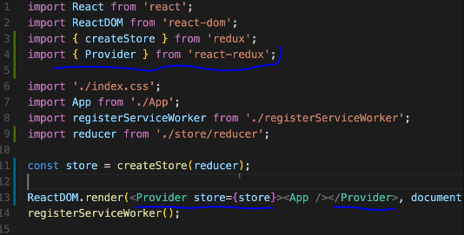

1. Now, connect the store to the container where the state need to be accessed, or to say otherwise we need to subscribe to the state. Can be achieved using feature provided by react-redux package.

Note: Always container (class-based) components will need to receive the state from the store and pass it on to the children.

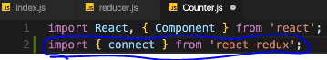

Connect is a function(or a higher order component) that will be passed two pieces of information. They are - the state we want to get and the action we want to dispatch

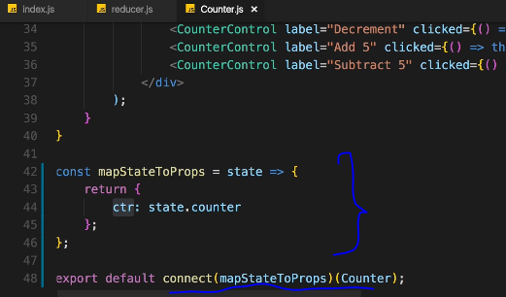

Now, we can use the state from redux as below:

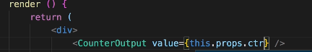

Now, dispatch the actions from within the containers as below

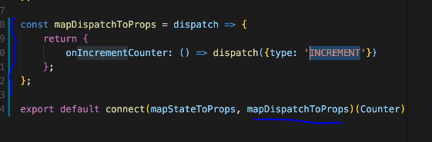

Now, handle this action in the reducer:

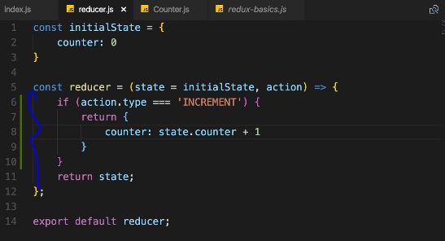

Now, to use the increment counter:

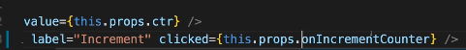

Values can also be passed in the dispatch as below. We can also pass payload object with any number of properties. Or can pass any number of properties.

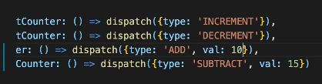

And use it in the reducer as below:

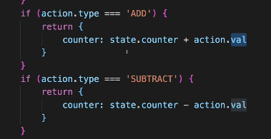

If statements can also be converted to below switch statements.

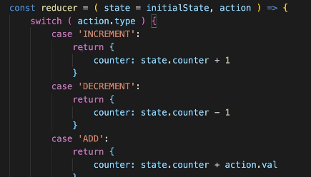

Updating State immutably:

As seen in below screen, state need to be updated immutably. Which means, a copy of the state need to be made and update has to be performed on that copy. That can be achieved in 2 ways as below: either by copying the old state(not deep copy - js objects are reference types) using object.assign or using spread operator which copies all the properties of the old state.

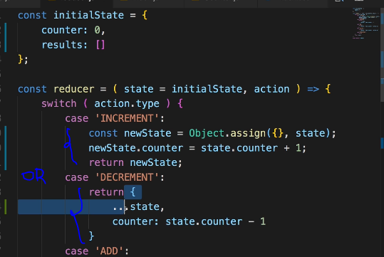

To add items to an array, use concat instead of push. Push will change the state and might be unpredictable.

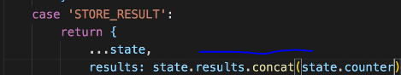

To delete an element from an array, simple use filter() to exclude element with the selected id

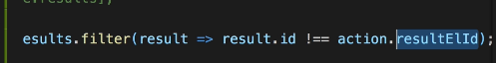

Immutable Update Patterns

Immutable Update Patterns on reduxjs.org: <https://redux.js.org/recipes/structuring-reducers/immutable-update-patterns/>

#### **Updating Nested Objects**

The key to updating nested data is **that every level of nesting must be copied and updated appropriately**. This is often a difficult concept for those learning Redux, and there are some specific problems that frequently occur when trying to update nested objects. These lead to accidental direct mutation, and should be avoided.

#### **Common Mistake #1: New variables that point to the same objects**

Defining a new variable does not create a new actual object - it only creates another reference to the same object. An example of this error would be:

1. function updateNestedState(state, action) {
2. let nestedState = state.nestedState;
3. // ERROR: this directly modifies the existing object reference - don't do this!
4. nestedState.nestedField = action.data;
6. return {
7. ...state,
8. nestedState
9. };
10. }

This function does correctly return a shallow copy of the top-level state object, but because the nestedState variable was still pointing at the existing object, the state was directly mutated.

#### **Common Mistake #2: Only making a shallow copy of one level**

Another common version of this error looks like this:

1. function updateNestedState(state, action) {
2. // Problem: this only does a shallow copy!
3. let newState = {...state};
5. // ERROR: nestedState is still the same object!
6. newState.nestedState.nestedField = action.data;
8. return newState;
9. }

Doing a shallow copy of the top level is not sufficient - the nestedState object should be copied as well.

#### **Correct Approach: Copying All Levels of Nested Data**

Unfortunately, the process of correctly applying immutable updates to deeply nested state can easily become verbose and hard to read. Here's what an example of updating state.first.second[someId].fourth might look like:

1. function updateVeryNestedField(state, action) {
2. return {
3. ...state,
4. first : {
5. ...state.first,
6. second : {
7. ...state.first.second,
8. [action.someId] : {
9. ...state.first.second[action.someId],
10. fourth : action.someValue
11. }
12. }
13. }
14. }
15. }

Obviously, each layer of nesting makes this harder to read, and gives more chances to make mistakes. This is one of several reasons why you are encouraged to keep your state flattened, and compose reducers as much as possible.

#### **Inserting and Removing Items in Arrays**

Normally, a Javascript array's contents are modified using mutative functions like push, unshift, and splice. Since we don't want to mutate state directly in reducers, those should normally be avoided. Because of that, you might see "insert" or "remove" behavior written like this:

1. function insertItem(array, action) {
2. return [
3. ...array.slice(0, action.index),
4. action.item,
5. ...array.slice(action.index)
6. ]
7. }
9. function removeItem(array, action) {
10. return [
11. ...array.slice(0, action.index),
12. ...array.slice(action.index + 1)
13. ];
14. }

However, remember that the key is that the original in-memory reference is not modified. **As long as we make a copy first, we can safely mutate the copy**. Note that this is true for both arrays and objects, but nested values still must be updated using the same rules.

This means that we could also write the insert and remove functions like this:

1. function insertItem(array, action) {
2. let newArray = array.slice();
3. newArray.splice(action.index, 0, action.item);
4. return newArray;
5. }
7. function removeItem(array, action) {
8. let newArray = array.slice();
9. newArray.splice(action.index, 1);
10. return newArray;
11. }

The remove function could also be implemented as:

1. function removeItem(array, action) {
2. return array.filter( (item, index) => index !== action.index);
3. }

#### **Updating an Item in an Array**

Updating one item in an array can be accomplished by using Array.map, returning a new value for the item we want to update, and returning the existing values for all other items:

1. function updateObjectInArray(array, action) {
2. return array.map( (item, index) => {
3. if(index !== action.index) {
4. // This isn't the item we care about - keep it as-is
5. return item;
6. }
8. // Otherwise, this is the one we want - return an updated value
9. return {
10. ...item,
11. ...action.item
12. };
13. });
14. }

#### **Immutable Update Utility Libraries**

Because writing immutable update code can become tedious, there are a number of utility libraries that try to abstract out the process. These libraries vary in APIs and usage, but all try to provide a shorter and more succinct way of writing these updates. Some, like [dot-prop-immutable](https://github.com/debitoor/dot-prop-immutable), take string paths for commands:

1. state = dotProp.set(state, `todos.${index}.complete`, true)

Others, like [immutability-helper](https://github.com/kolodny/immutability-helper) (a fork of the now-deprecated React Immutability Helpers addon), use nested values and helper functions:

1. var collection = [1, 2, {a: [12, 17, 15]}];
2. var newCollection = update(collection, {2: {a: {$splice: [[1, 1, 13, 14]]}}});

They can provide a useful alternative to writing manual immutable update logic.

Always Best practice to store constants in a separate file(outsource) for easy maintenance and to avoid any possible issues.

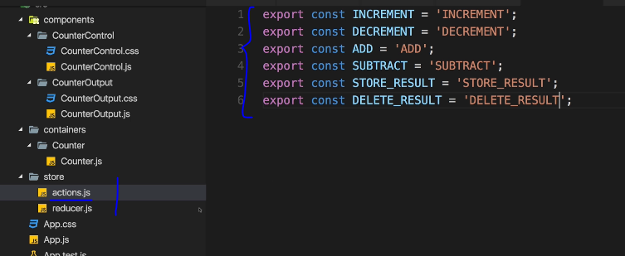

Import to any file

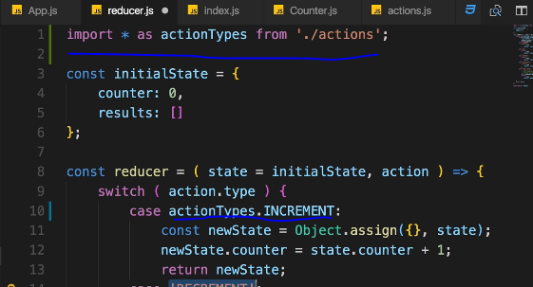

Combining multiple reducers:

Multiple reducers can be created to handle different parts/features of the application. Redux provides a utility to combine all reducers into one. The below image shows combinereducers function that takes a javascript object where we can pass multiple reducers. Redux will combine all the reducers into one single one.

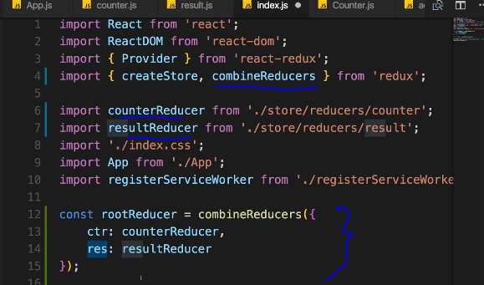

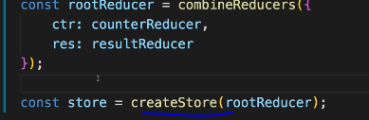

Now, to access the values from the combined reducer, need to access using the reducer object key as below:

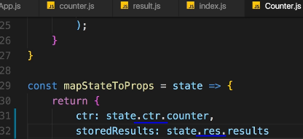

No need to use redux everywhere, as it might be an overkill for smaller modules/project.

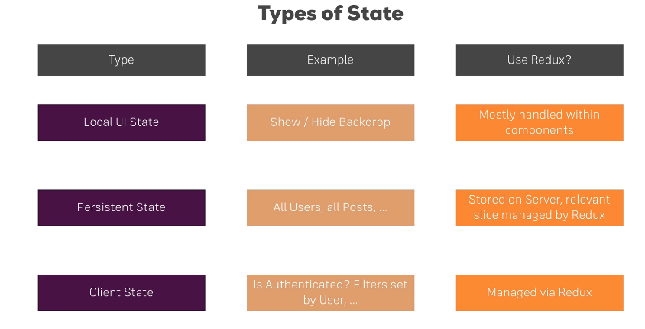

Adding MiddleWare (function that can perform in middle actions) in Redux: Before dispatching the actions to the reducer.

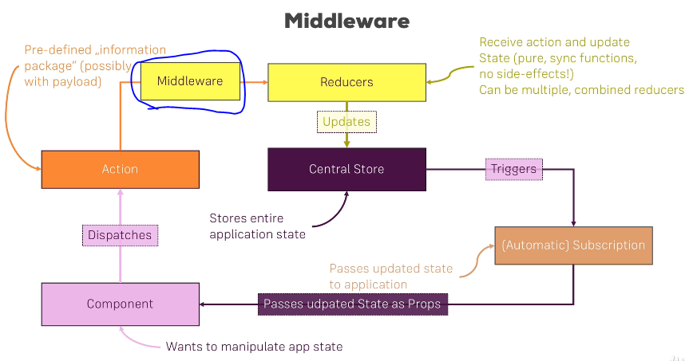

Adding middleware in index.js

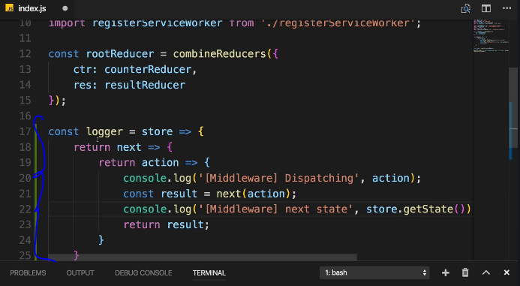

Import ‘applymiddleware’ and pass it to the store. Any number of middleware can be added with comma separation.

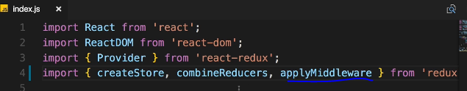

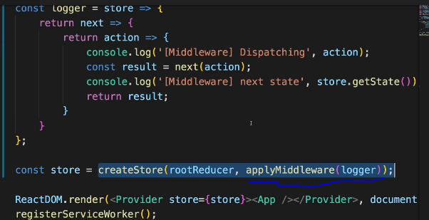

Redux devtools extension

<https://github.com/zalmoxisus/redux-devtools-extension>

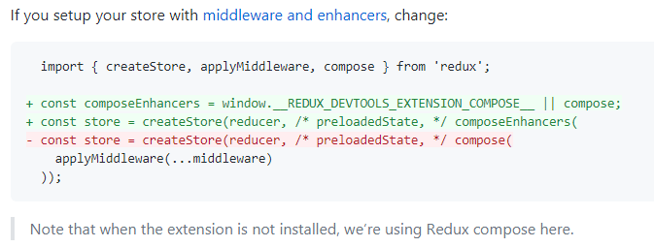

# Executing asynchronous code: using Action creators

Using action creators synchronously:

Creating action creators as a function as below. These action creators should start with a lower case.

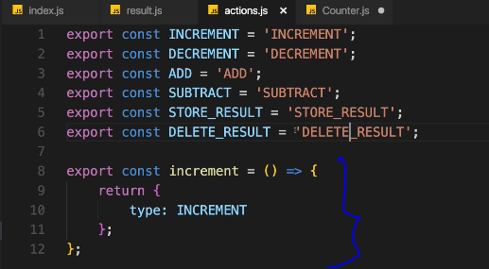

Now, import that function to js file as below

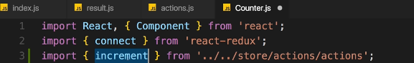

Use in the dispatch to reducer as below

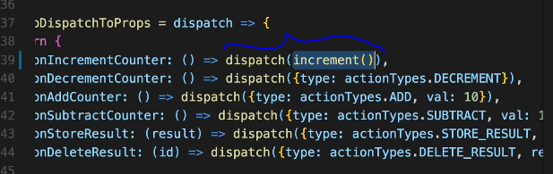

Passing payload in an action creator

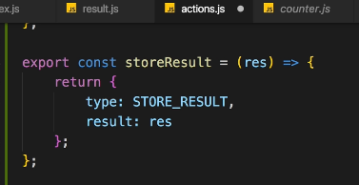

Asynchronous code using redux-thunk:

<https://github.com/reduxjs/redux-thunk>

With a plain basic Redux store, you can only do simple synchronous updates by dispatching an action. Middleware extends the store's abilities, and lets you write async logic that interacts with the store.

Thunks are the recommended middleware for basic Redux side effects logic, including complex synchronous logic that needs access to the store, and simple async logic like AJAX requests.

1. Npm install –save redux-thunk
2. Import thunk from ‘redux-thunk’
3. Add thunk to the store applymiddleware function



1. Example usage. Thunk returns a function with dispatch

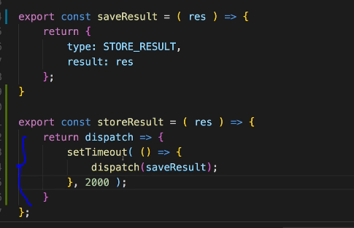

Where to put the logic of data transformation and update?

Chose either one for the project rather than having in both places. Preference is reducer where the logic need to happen.

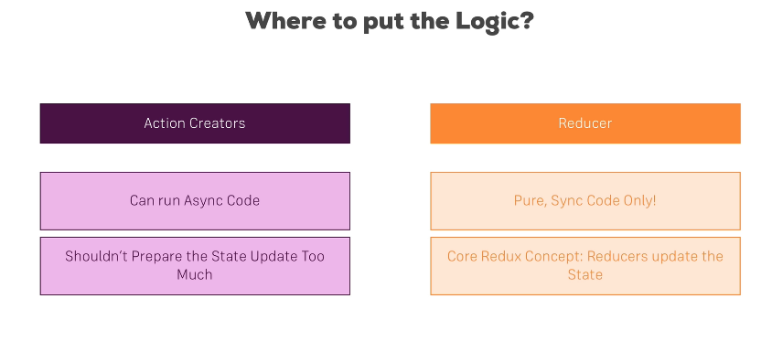

Redux-thunk can also pass a second argument that can give the old state and can be used to read old stt data for saving into database or for any other manipulations. Not recommended to use a lot, instead pass paramateres to dispatch.

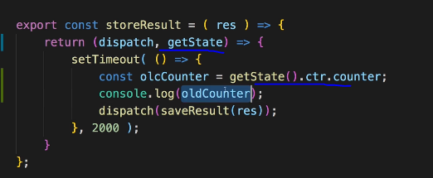

Redux references:

<https://redux.js.org/tutorials/essentials/part-1-overview-concepts>

Middleware: https://redux.js.org/advanced/middleware/

redux-thunk package: https://github.com/gaearon/redux-thunk

Async Actions: https://redux.js.org/advanced/async-actions

# Authentication



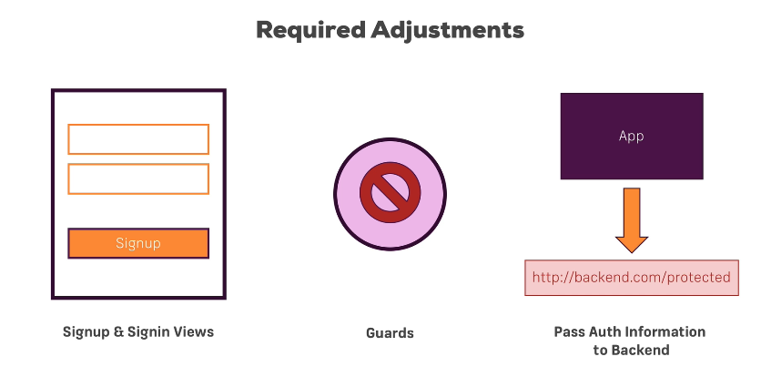

-Persistent Auth state can be achieved using localStorage

localStorage.setItem(‘token’, response.data.idToken)

localStorage.getItem(‘token’)

Ensuring App security: To ensure app security when using local storage, and to avoid Cross site scripting where the token can be accessed – use refresh token with token expiration (60 mins or other) to generate a new token on every http request or after 60 mins.